**ASP Project: Gaming Website Project**

**Abstract:**

1. In this project, I have made use of some coding languages to creates games and then I have put them on a single website that a user can access to play these games.

Technology Used: HTML, javaScript, CSS3

Text Editor: Notepad++

**About the Project:** I have created a website with three games available to play on it. These games are called Strike, Lucky and Fish games. The website features a good themed background and various pages as per the games. The user can select a game from the home page by clicking their favorite game. The website also features a top navigation bar so that the user can go to home page or switch between games anytime or see the contact Information.

* 1. Fish:
     1. Objective: The fish is trying to reach in the end by crossing several obstacles. The user must help the fish by making it swim across the water with keyboard and mouse controls.
     2. How to Play: The user can click any button on keyboard to start the game and keep the fish swimming in the water. The user can also use mouse click to make the fish swim.
  2. Strike:
     1. Objective: The user should be able to clear all the blocks by hitting with the ball to win the game.
     2. How to Play: Use the mouse to hover right or left to catch the ball and do not let it fall below the bar at the bottom. The user can also use right or left arrow keys to move the bar to catch the ball. Once the user clears all the block by hitting the ball, the page will announce them as winner.
  3. Lucky:
     1. Objective: This is a very minimalistic game where the user can get their lucky number and fortune.
     2. How to Play: As soon as the page loads, the cursor is shifted to the one and only text box on the page and asks the user to enter their name. The user should enter their name in the text box and then hit the button below it to see what their lucky number and their fortune is.

Below are the screenshots of the website explaining all the features

1. The game homepage: At the top of the homepage, the user can find the names of all games on the top navigation bar and link to contact us page.

The user can click on the “Get started” button to scroll the page further down to see all the available games.

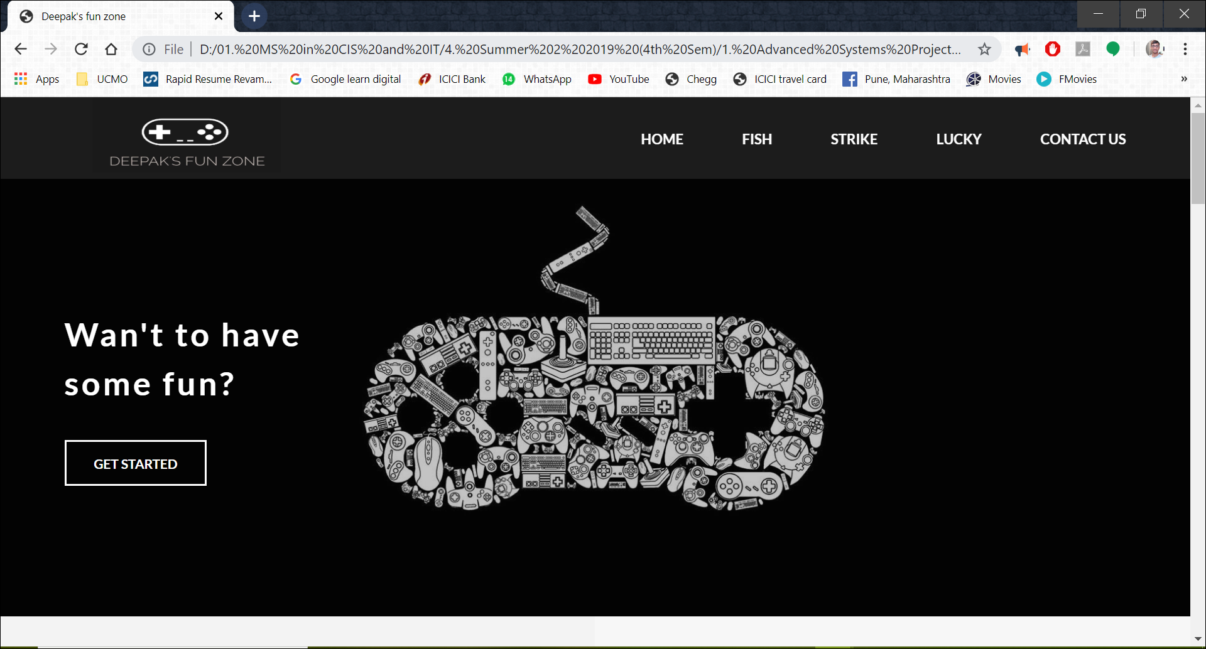

1. This screen appears when the user clicks the “Get started” button. After clicking the “Get started” button, the homepage is automatically scrolled down to the first two available games called Strike and Fish Game. The user can click on the game picture to go directly to the referenced game page.

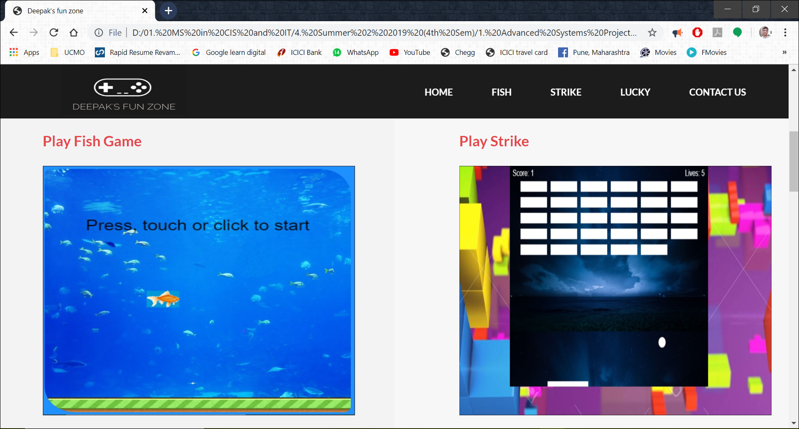

1. The user can further scroll below to see the next available game called as Lucky. The user can click on the game picture to go directly to the referenced game page.

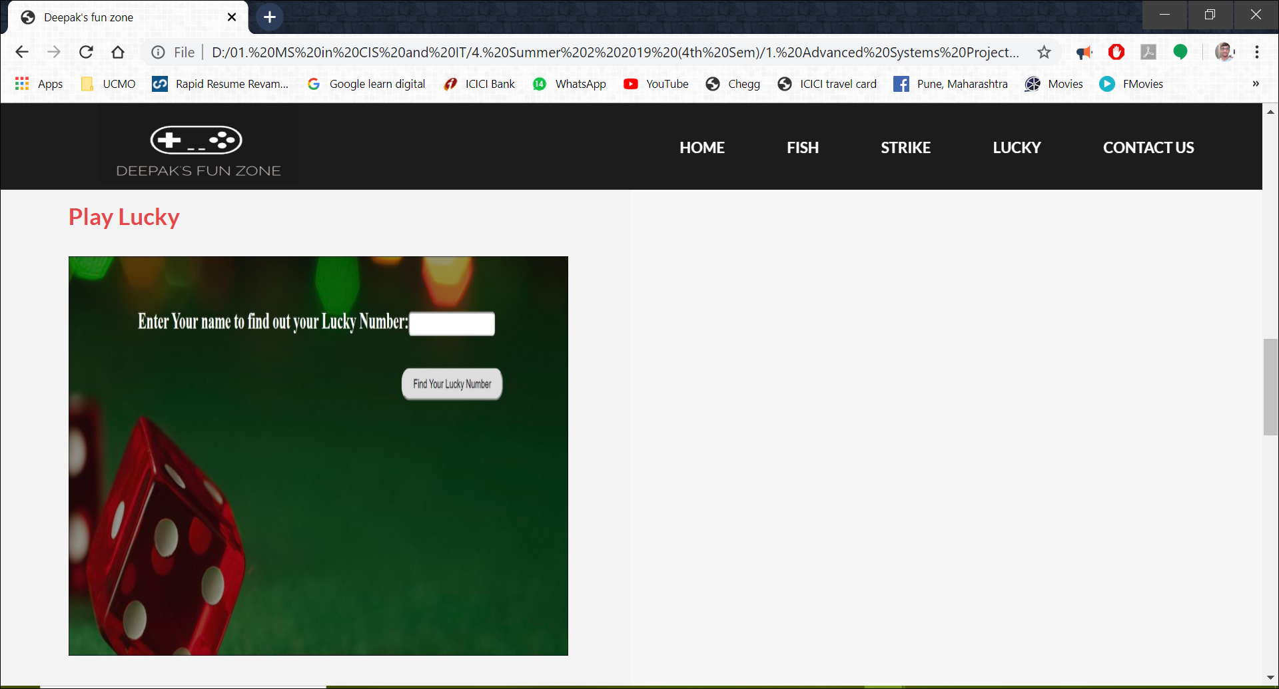

1. The user can use the navigation bar to click on any game name from any of the screens, like the homepage or any game page, to go to either homepage or any different game page or the contact us page.



1. Below the games page, the details of the Instructor and Student can be found with their pictures. The user can click on the “LEARN MORE” button for more details.

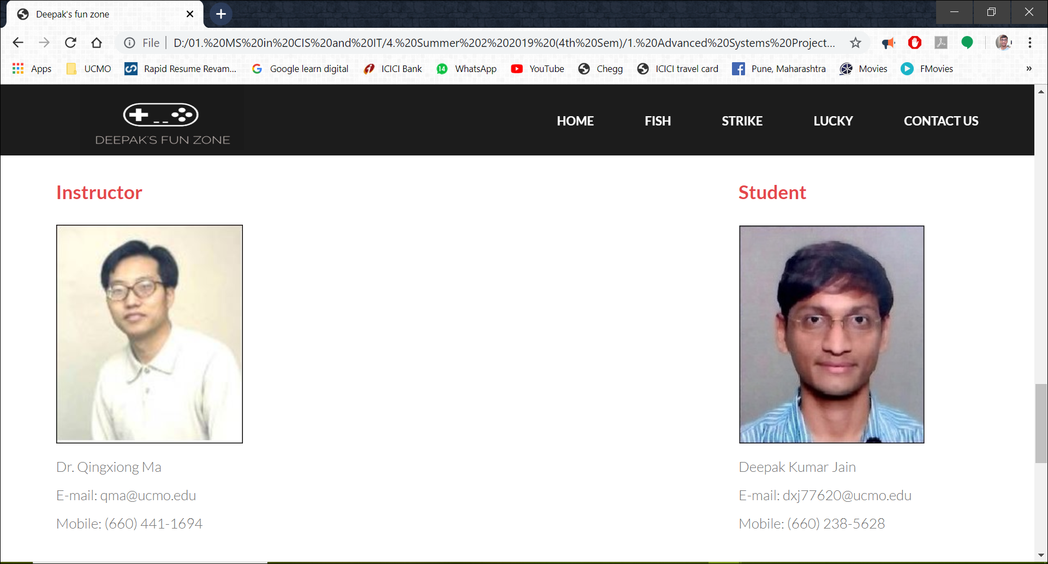

1. After the user clicks on the “LEARN MORE” button they would land up on contact us page for more information

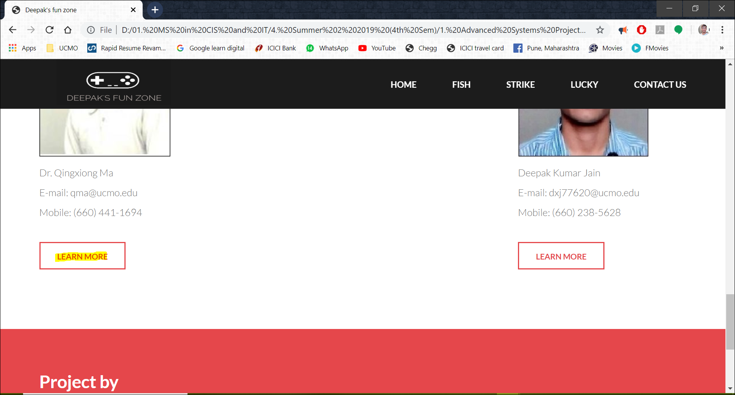

1. Once the user clicks on the “LEARN MORE” button, they would go to the contact us page.

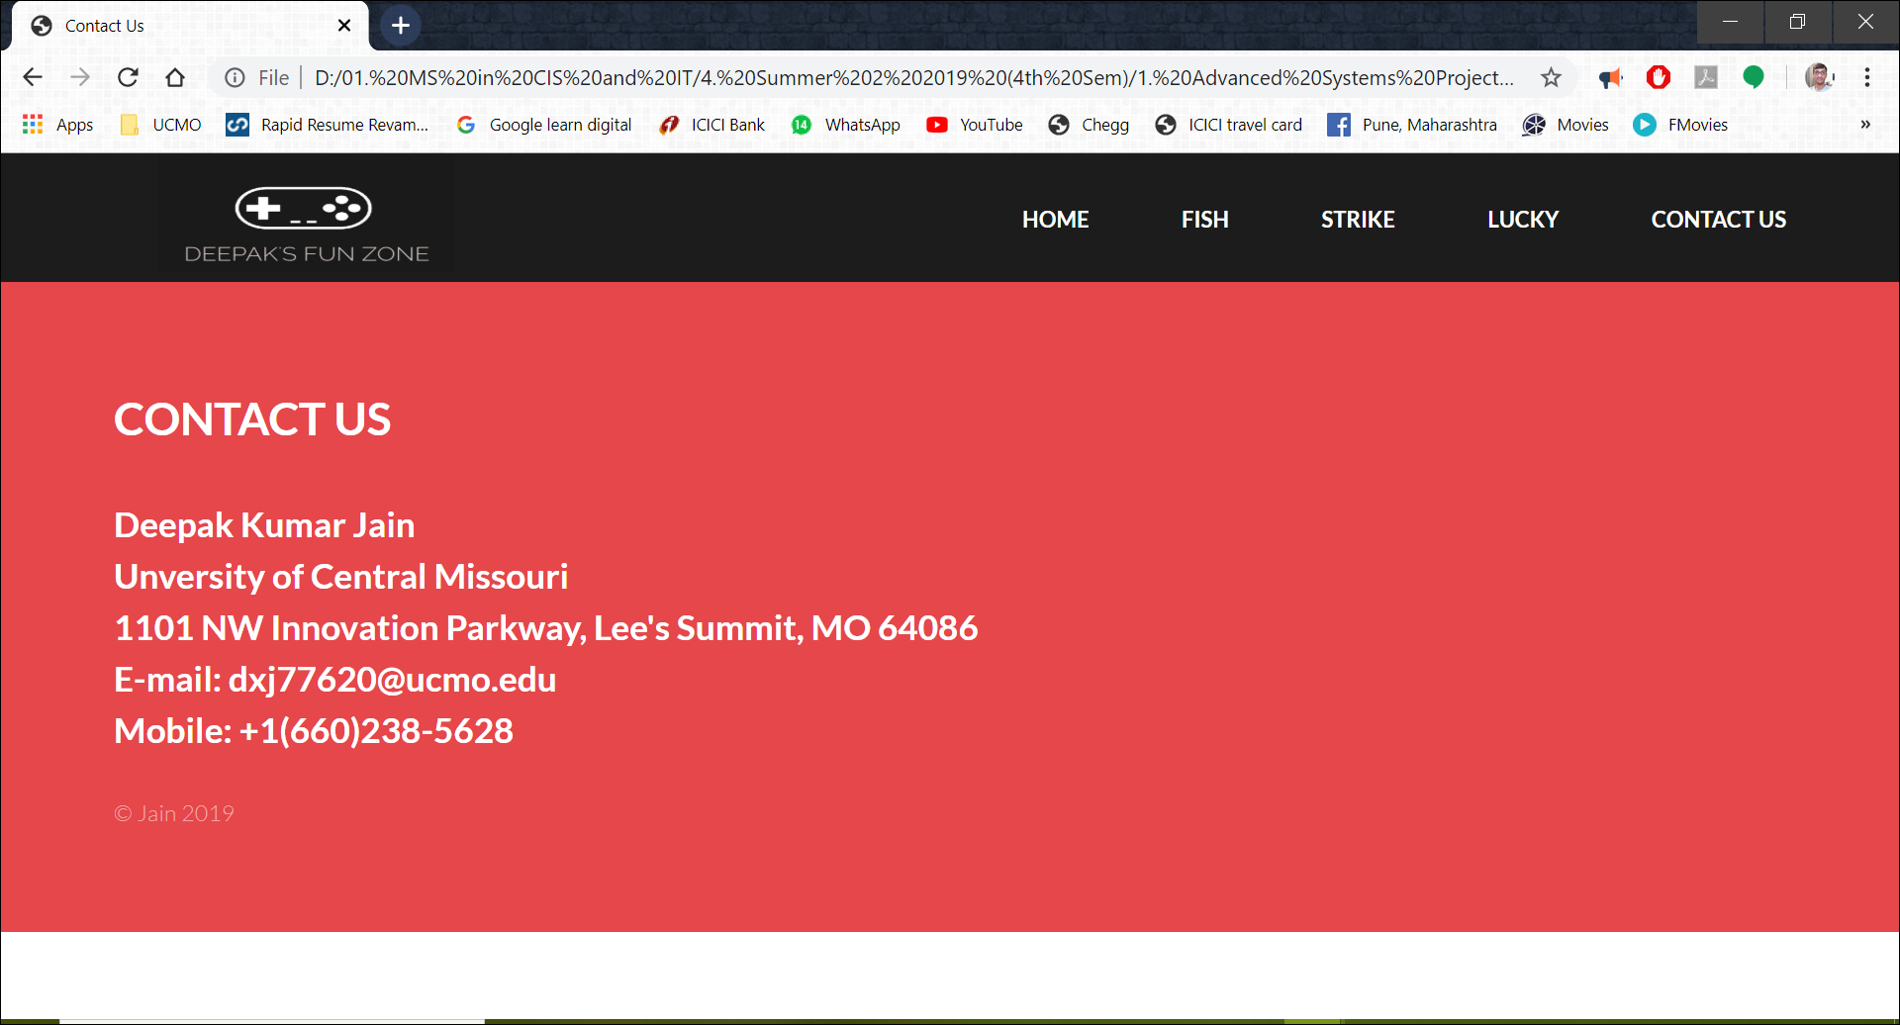

1. Screenshots of the contact us code are below

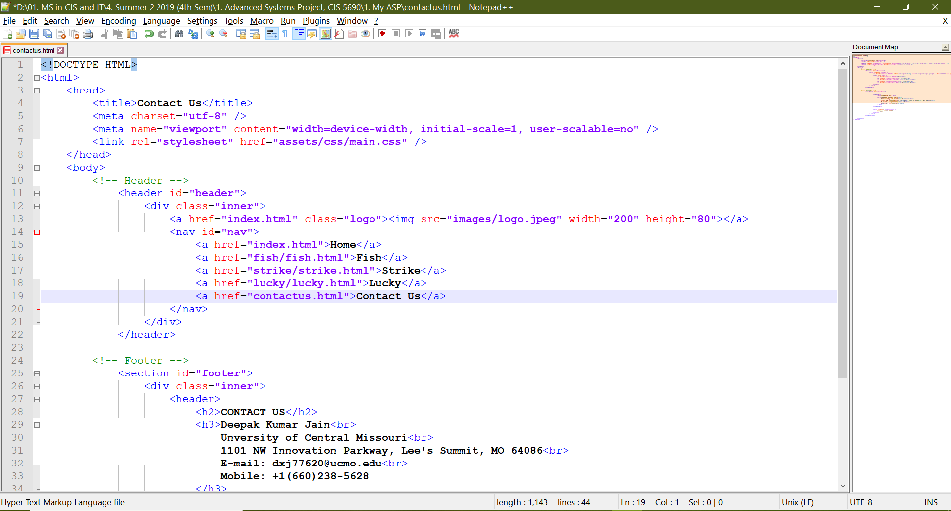

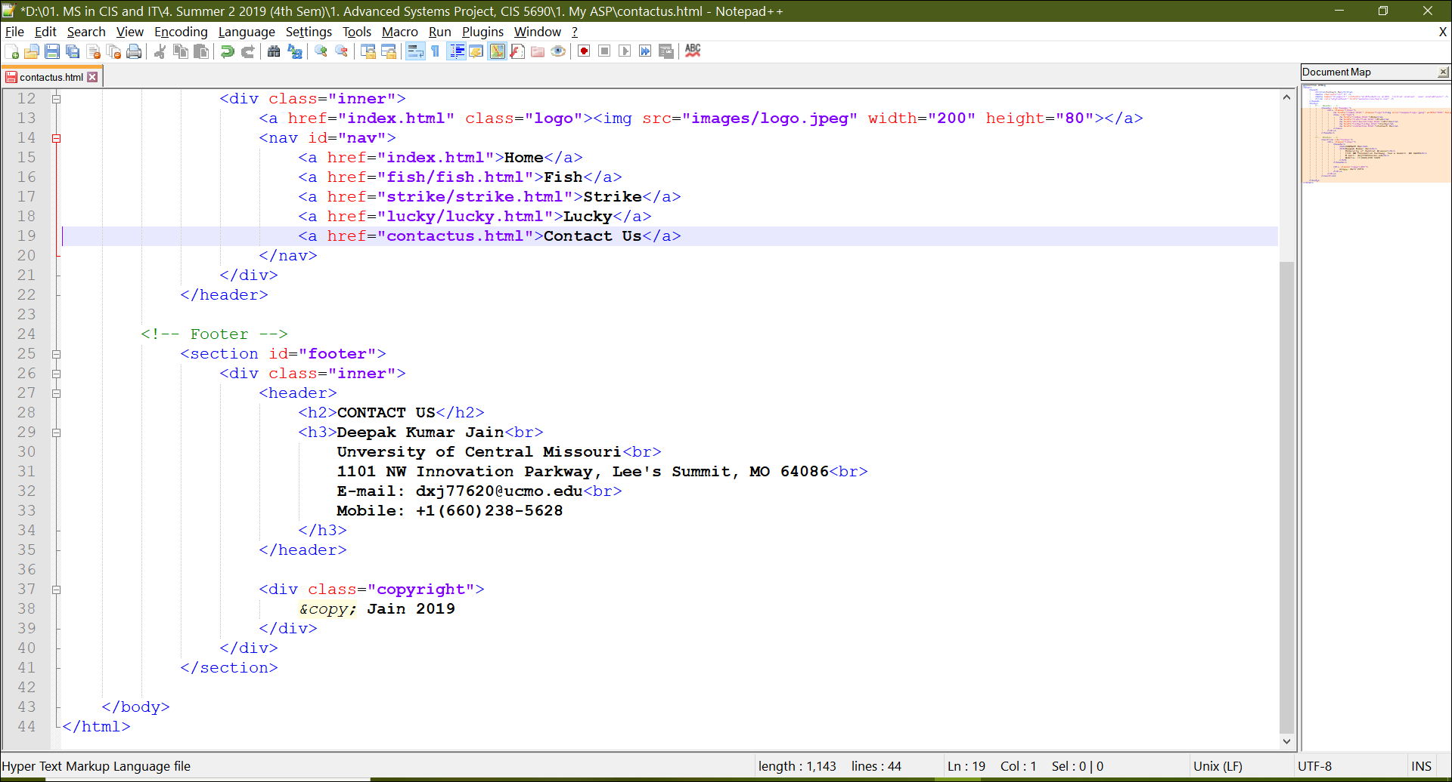

1. Each game features some information about them on the home page as can be seen in the below screen

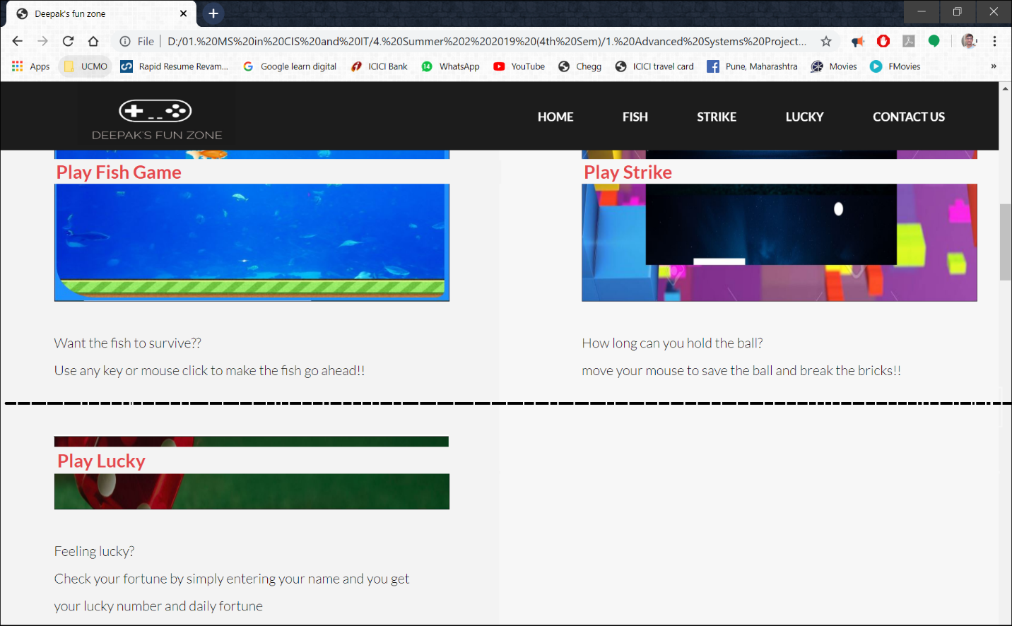

1. Below the Instructor and Student details, the project details are mentioned

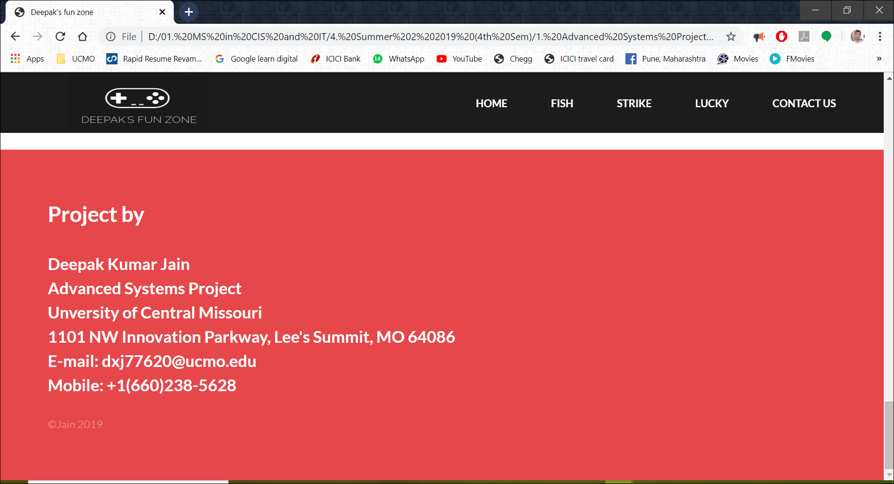

1. The user can click the logo to come to homepage anytime



1. Below are the screen shots for the homepage

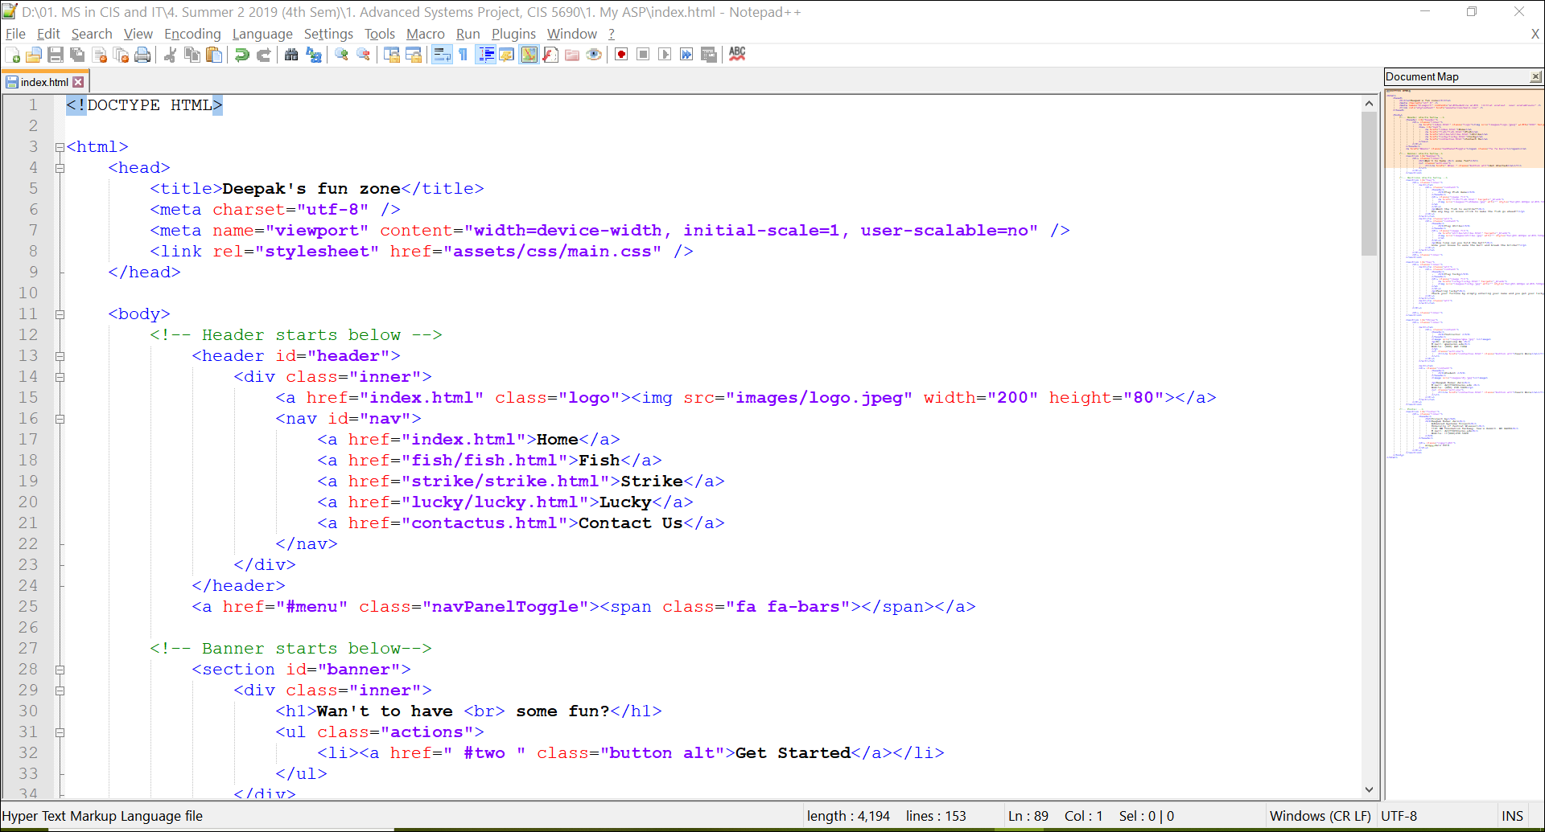

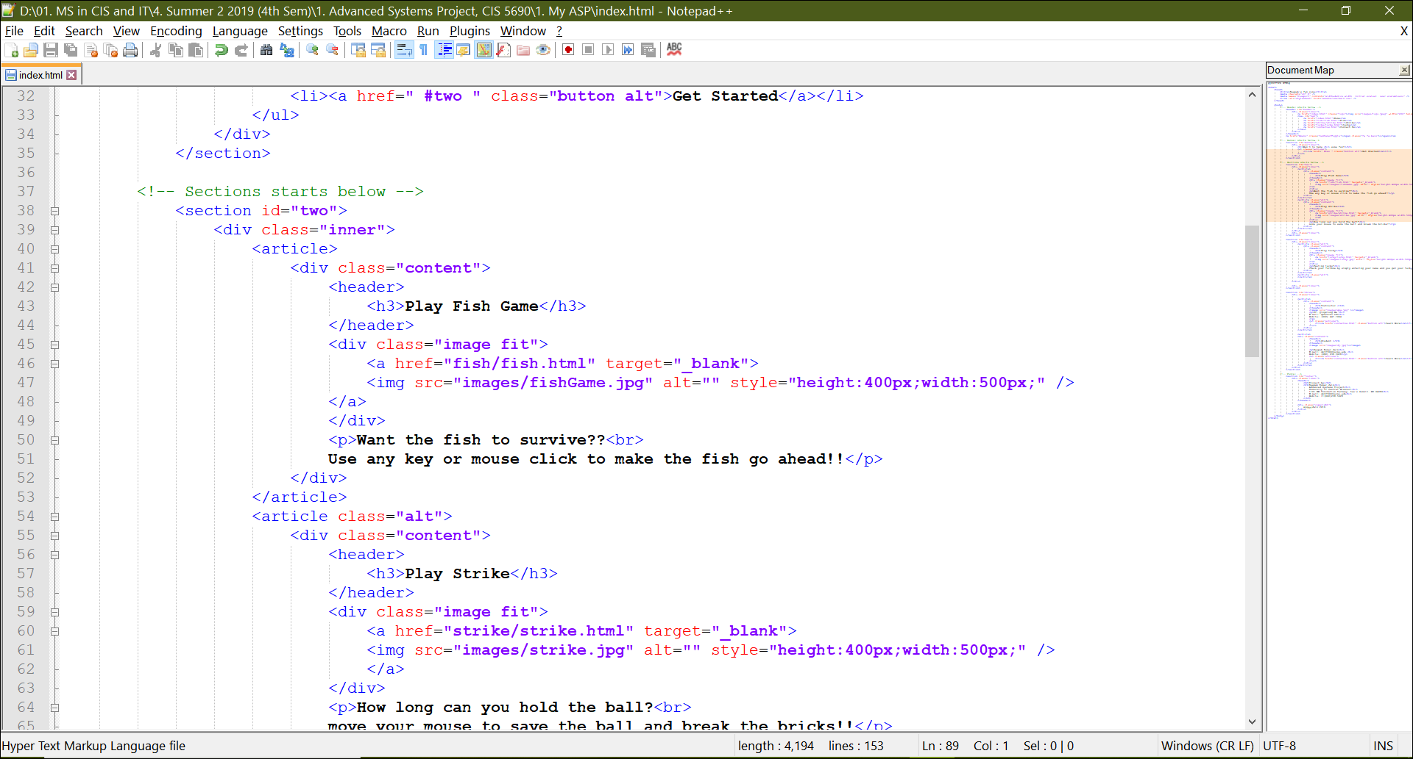

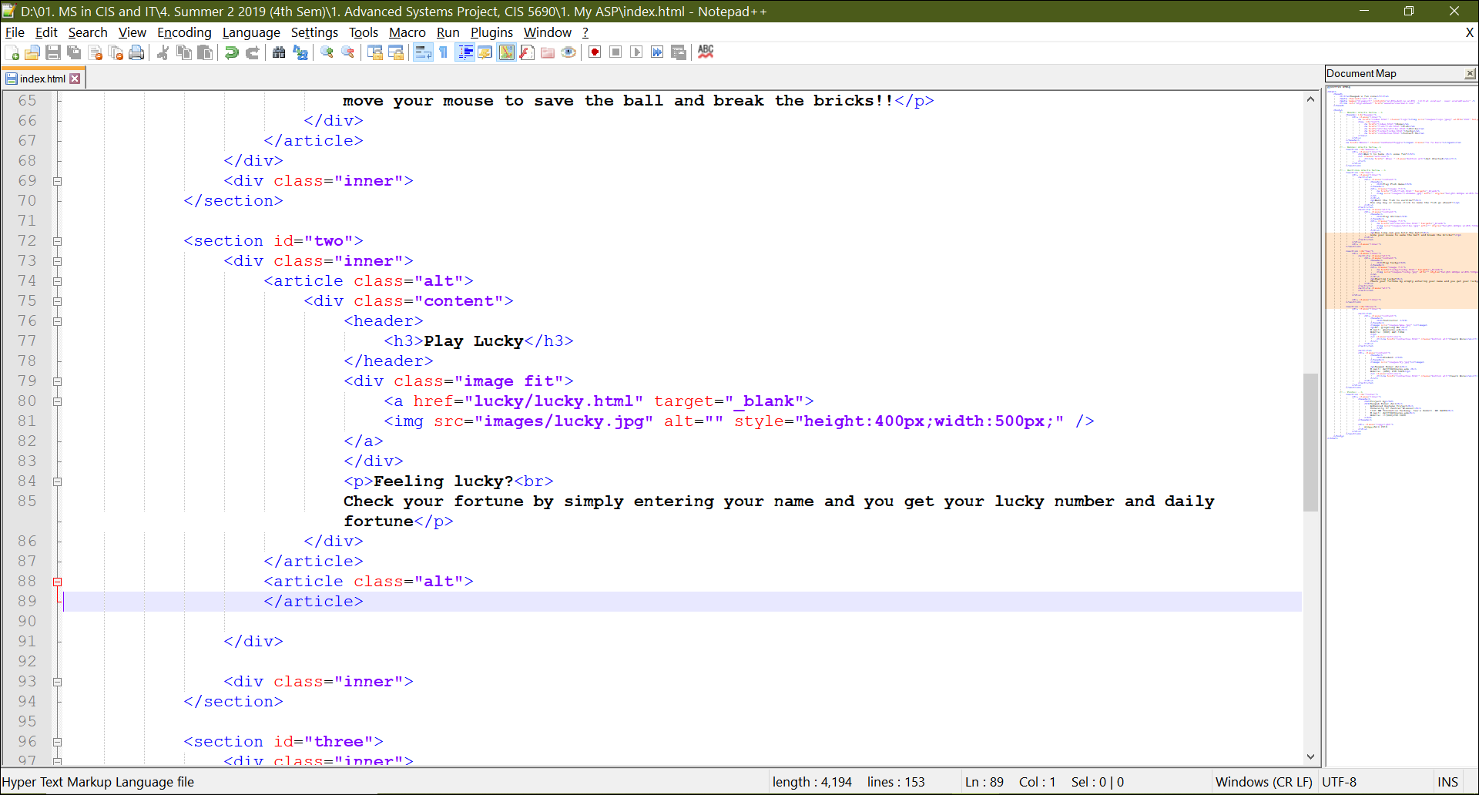

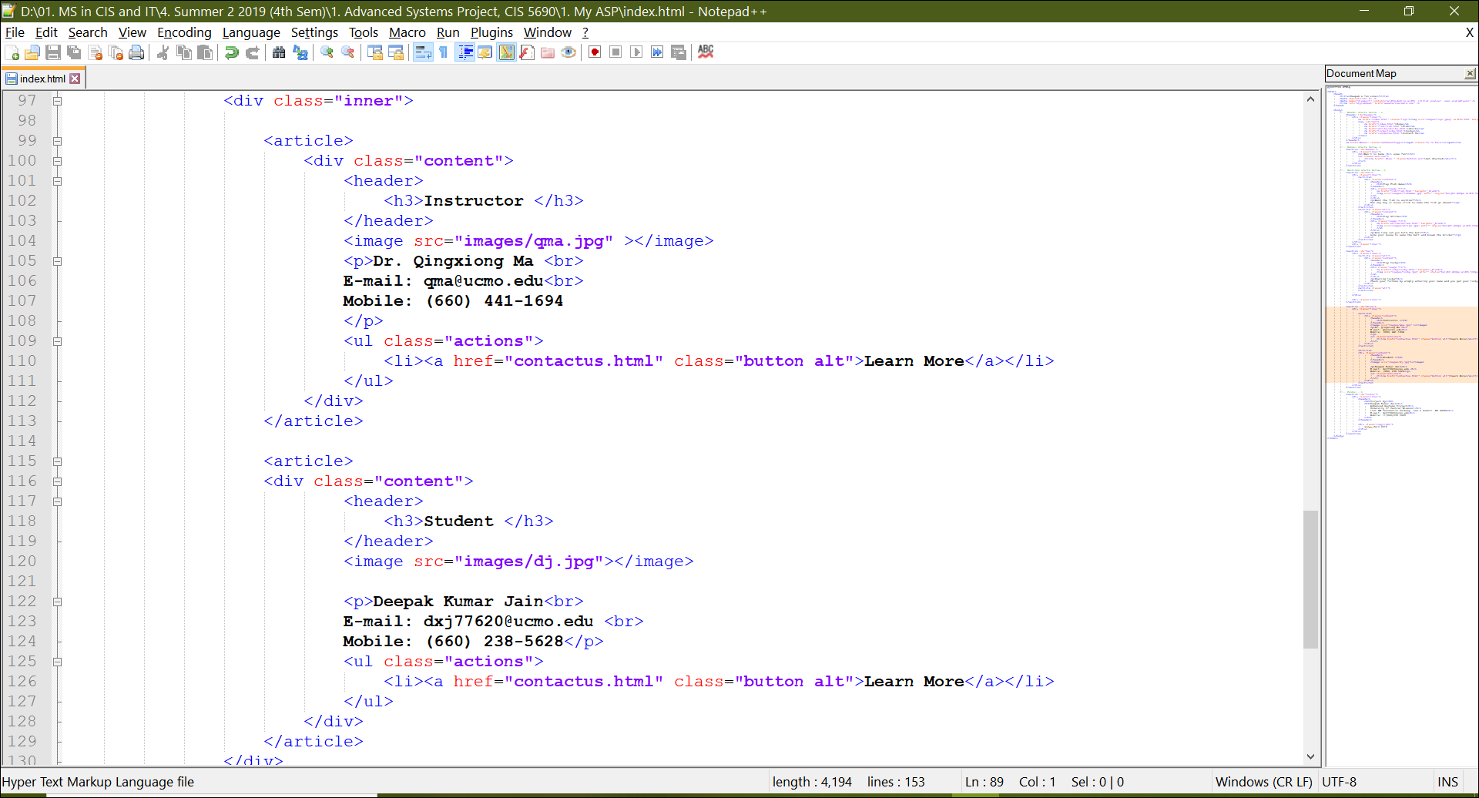

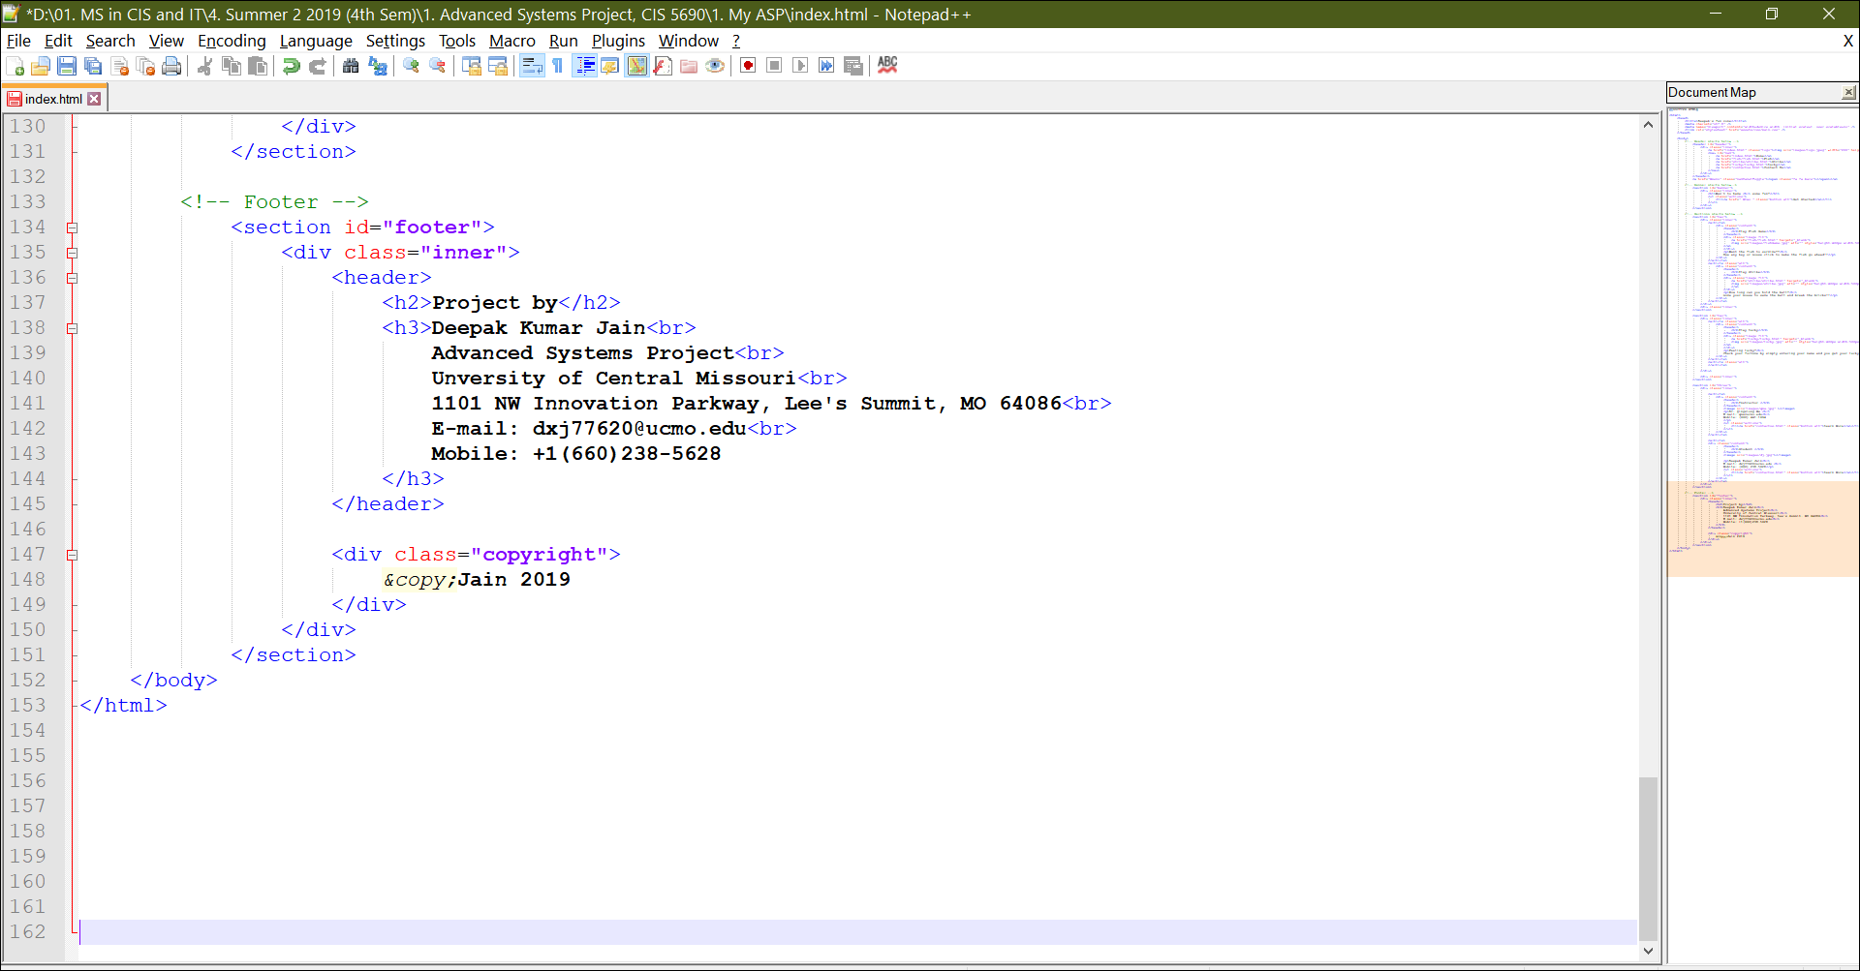

1. When the user clicks Fish Game, He is automatically navigated to the game page that looks like the below screenshot.

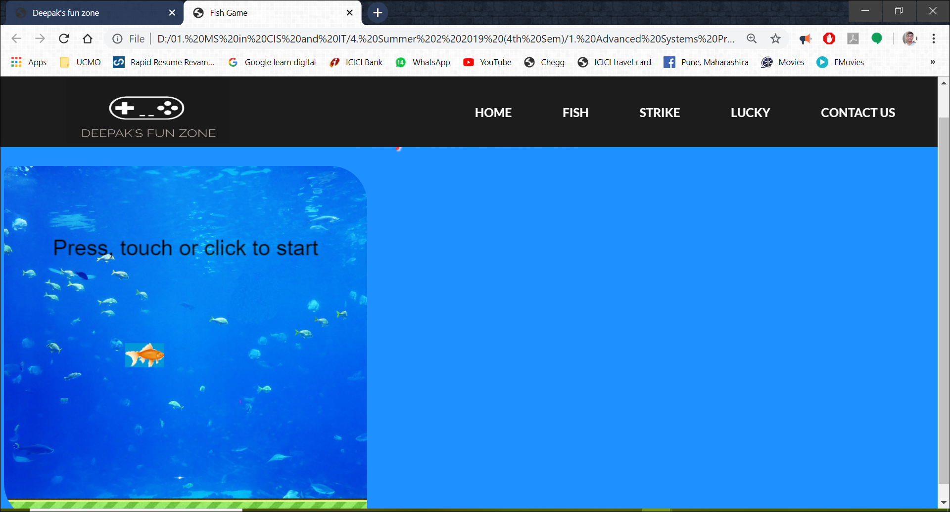

1. The user can start playing this game by clicking mouse button, touching the screen or pressing any button on the keyboard. Once the button is hit, the game begins, and user is expected to make the fish swim until it clears the last obstacle in its path.

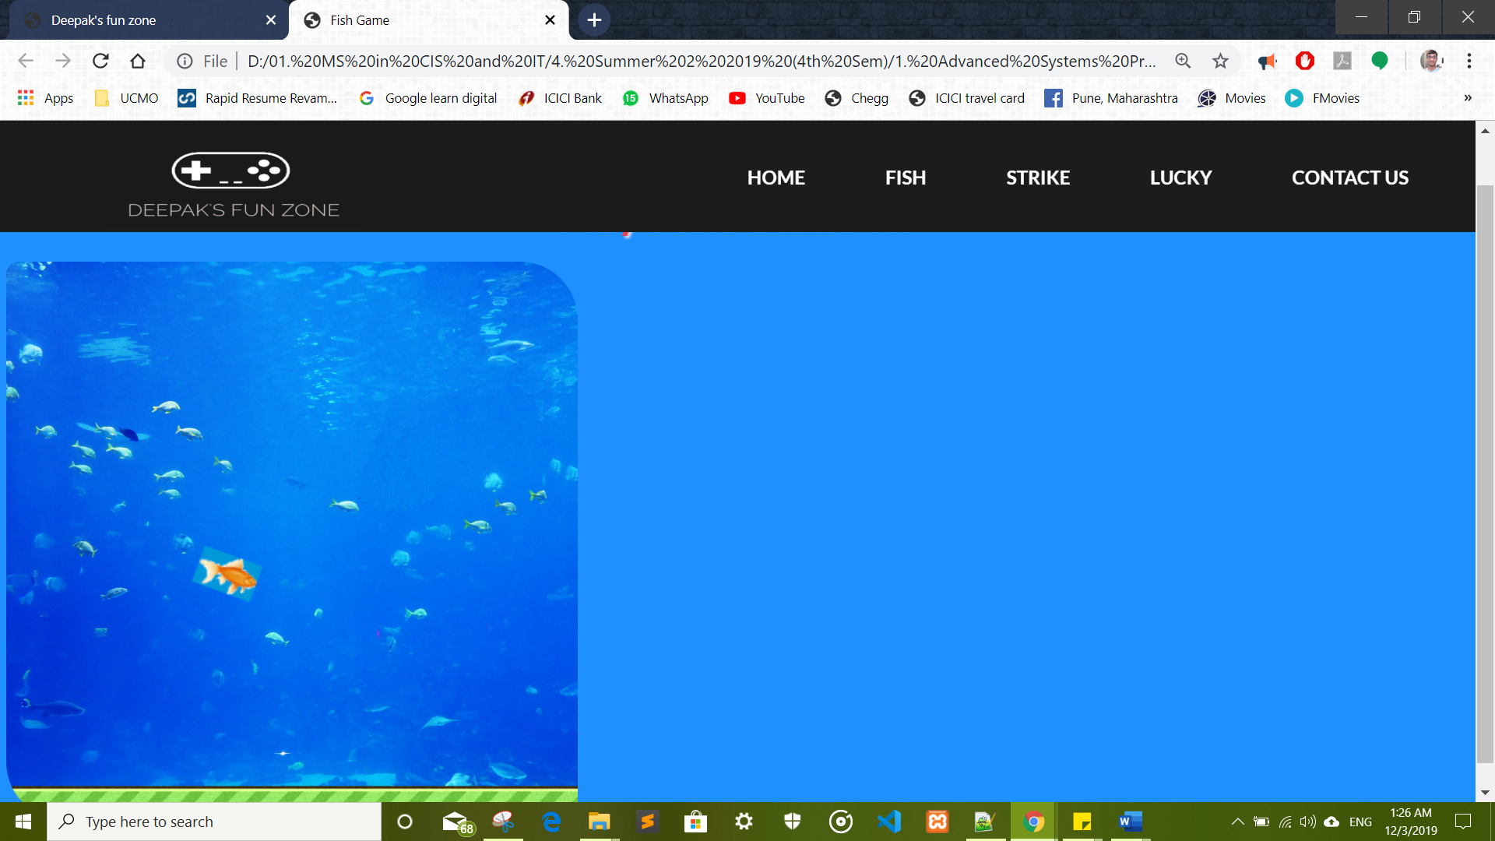

1. The obstacles are as some grass that grows under water

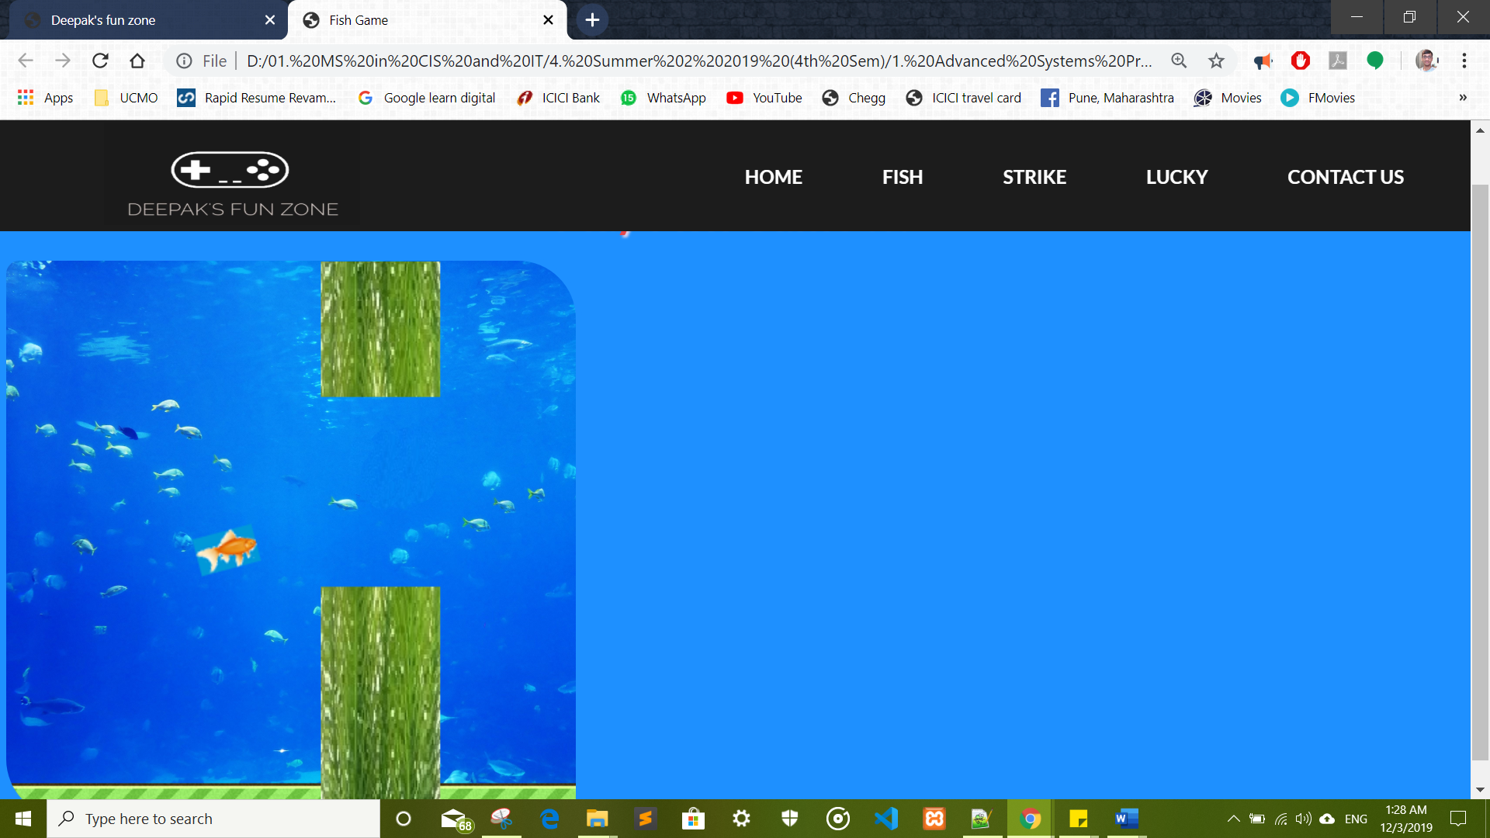

1. The user clicks the button on the mouse or presses on ley board to make the fish swim and cross all obstacles.

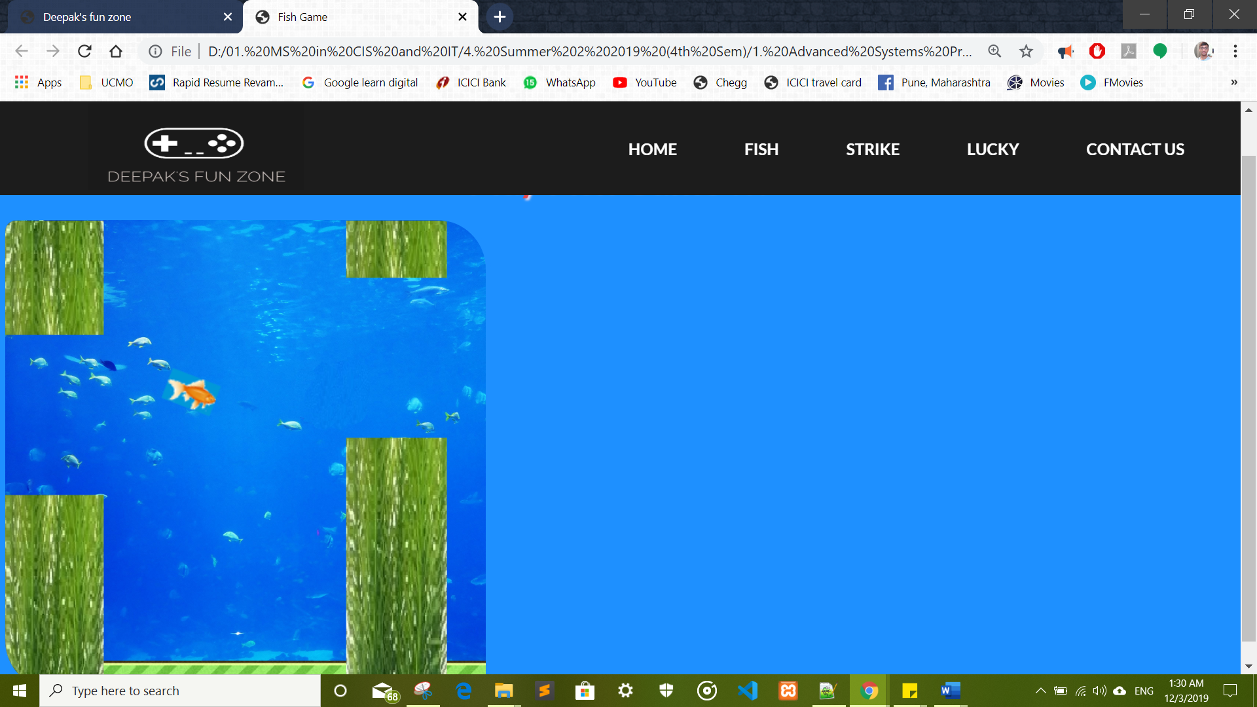

1. The game is over if the fish touches any grass like obstacle.

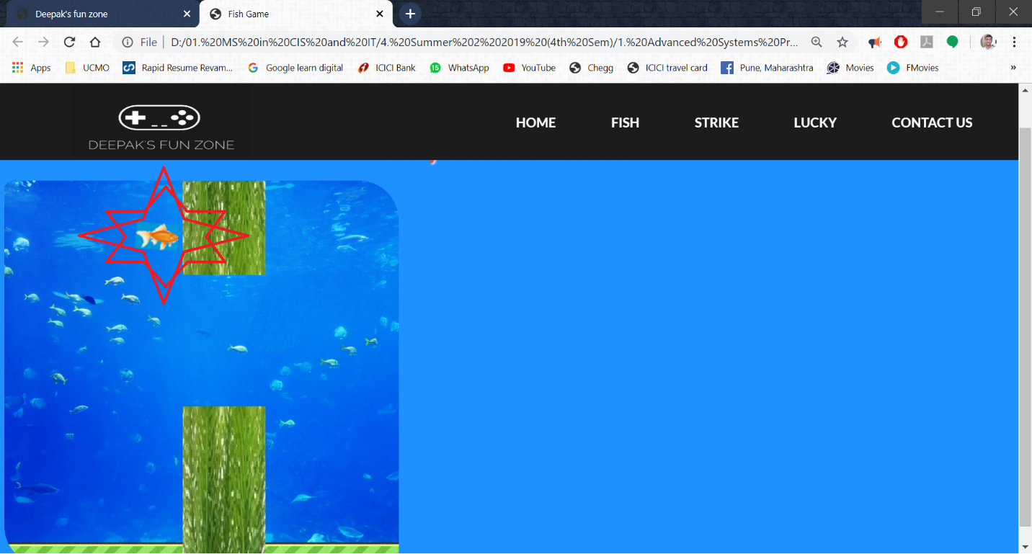

1. The game is over and user can see their score on the screen like in the below screen shot

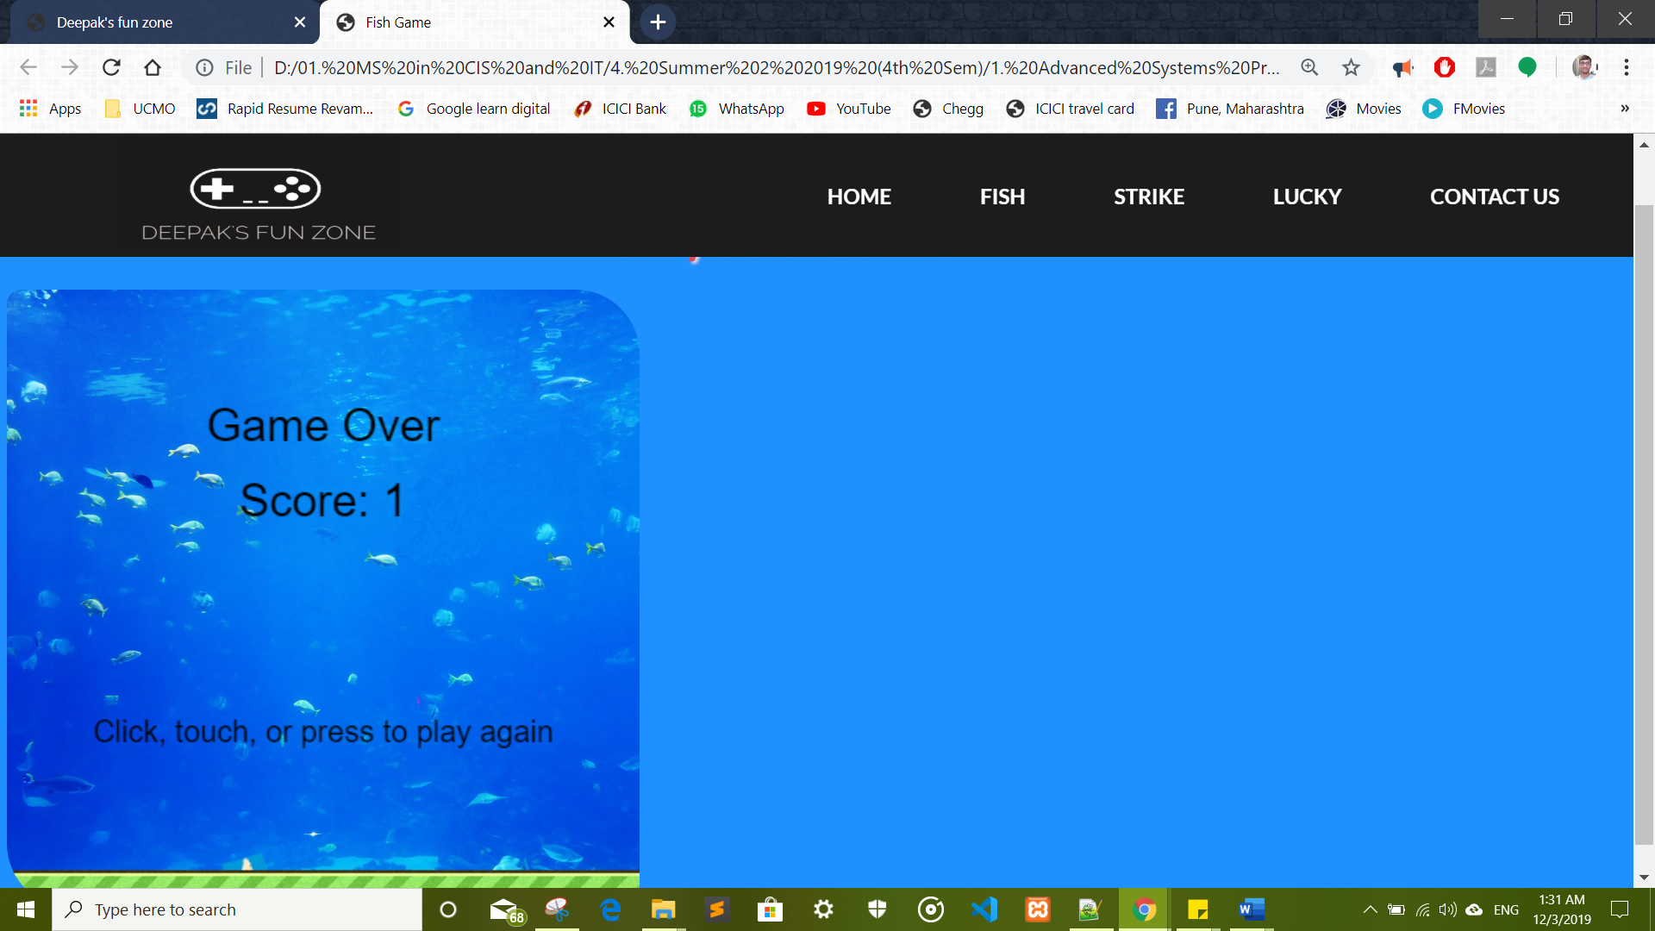

1. The game is also over if the fish goes below green bar at the bottom of the screen.

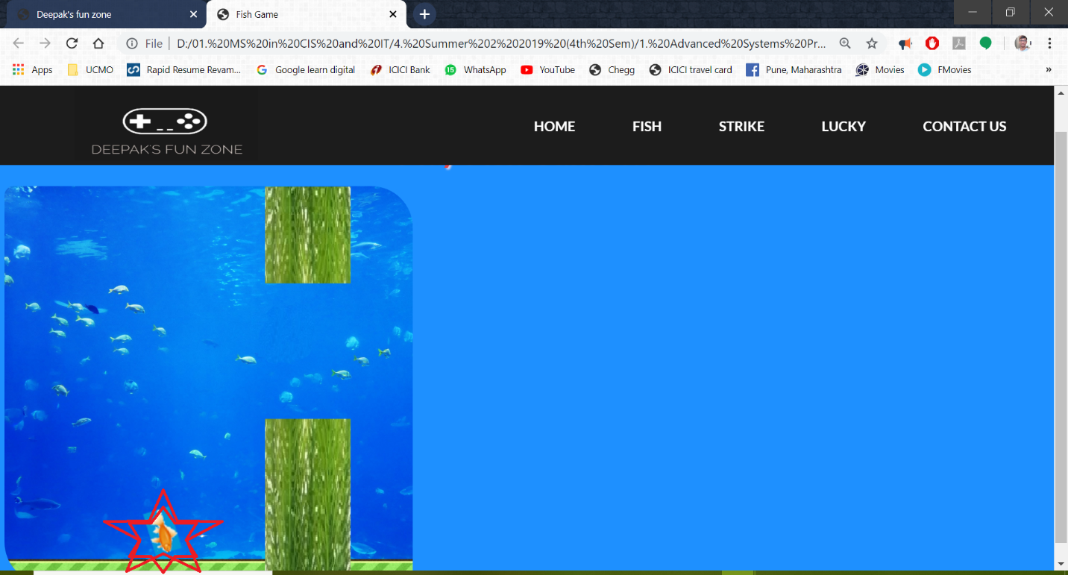

1. The game is over and user can see their 0 score on the screen like in the below screen shot.

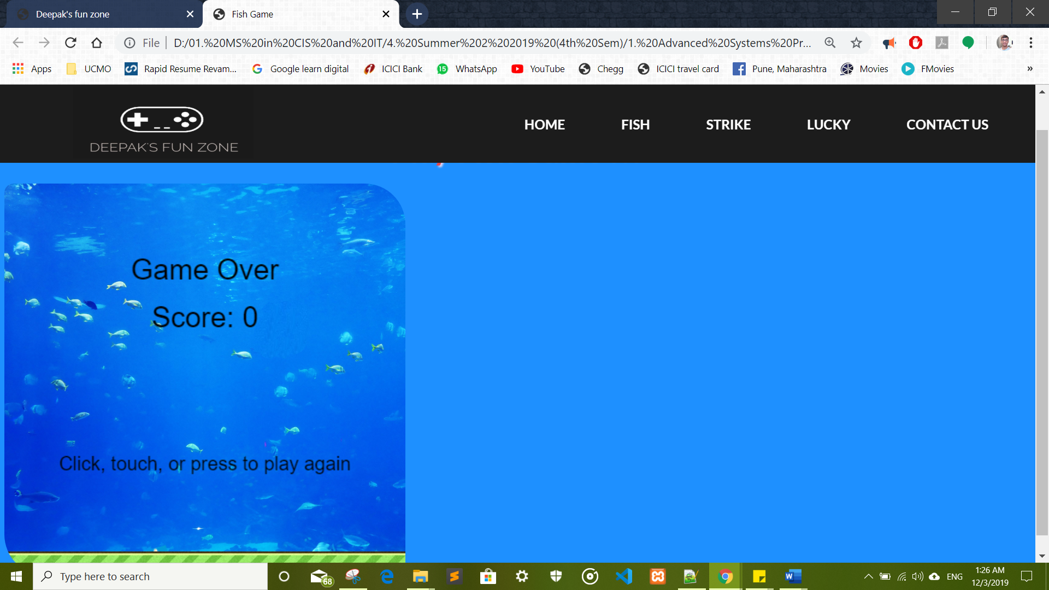

1. Once the fish touches the finish line, the user is displayed a winning message on the screen.

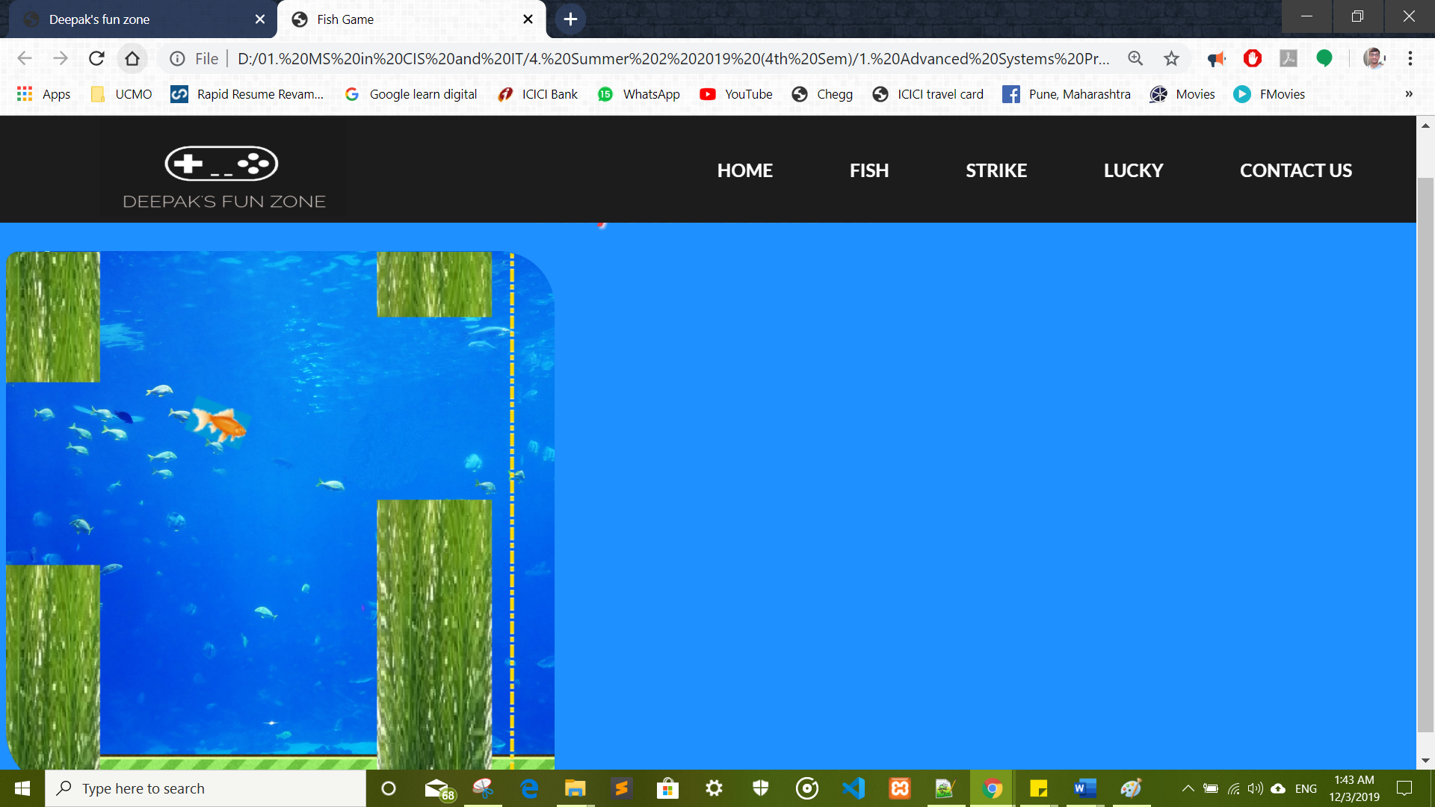

1. Screenshots of the code for the fish game

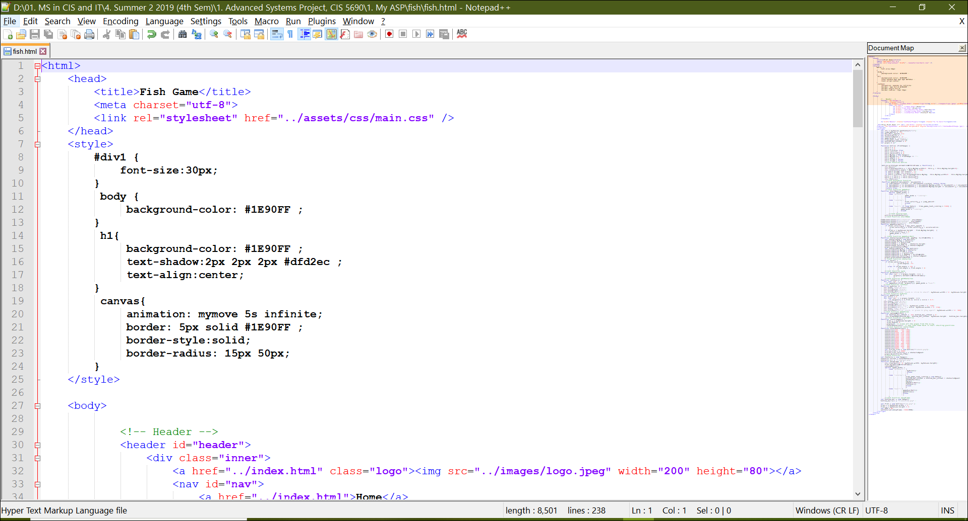

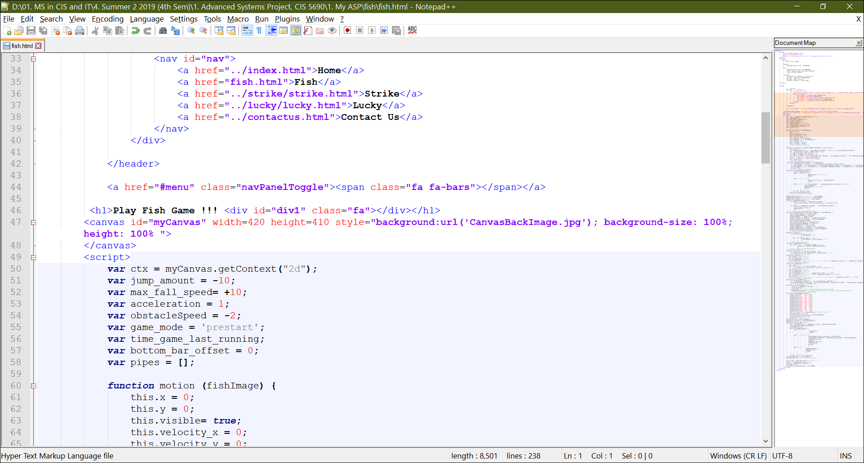

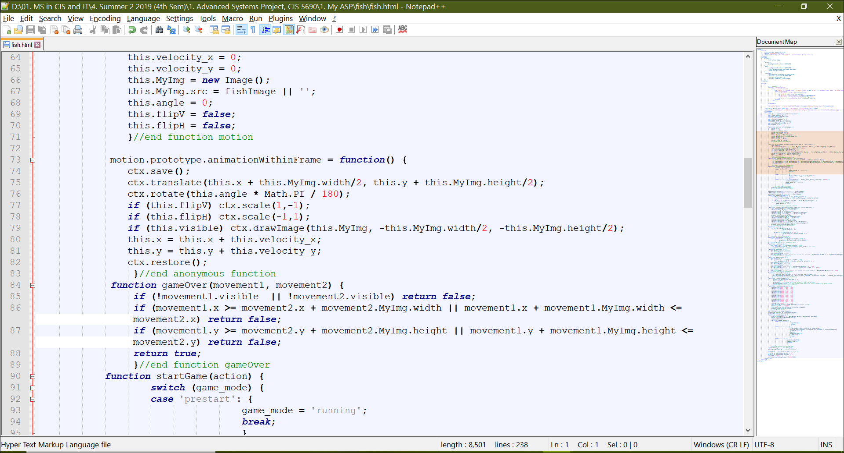

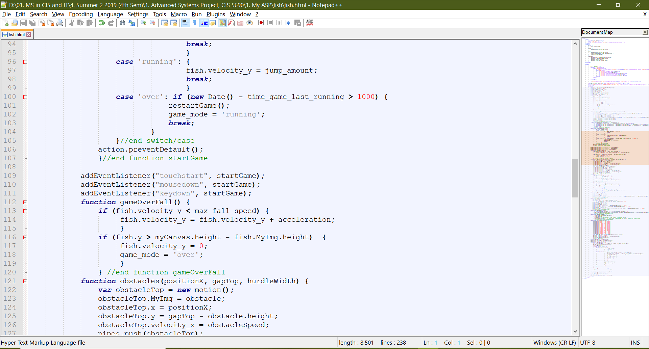

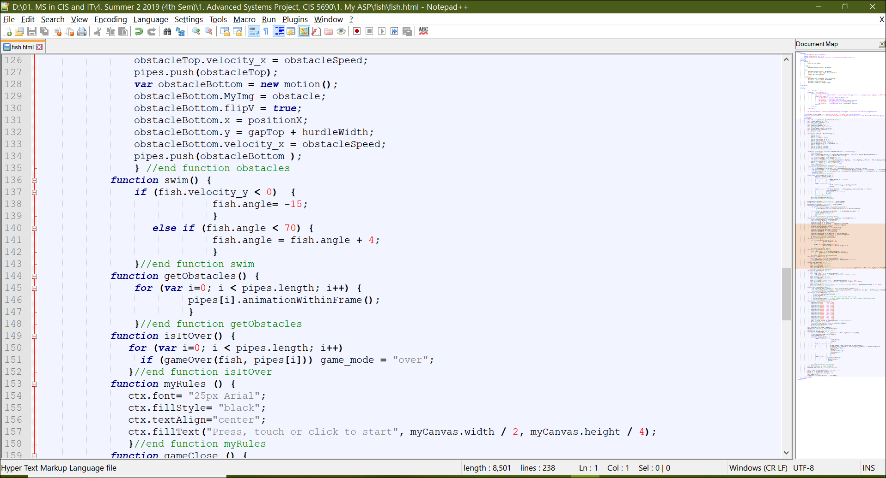

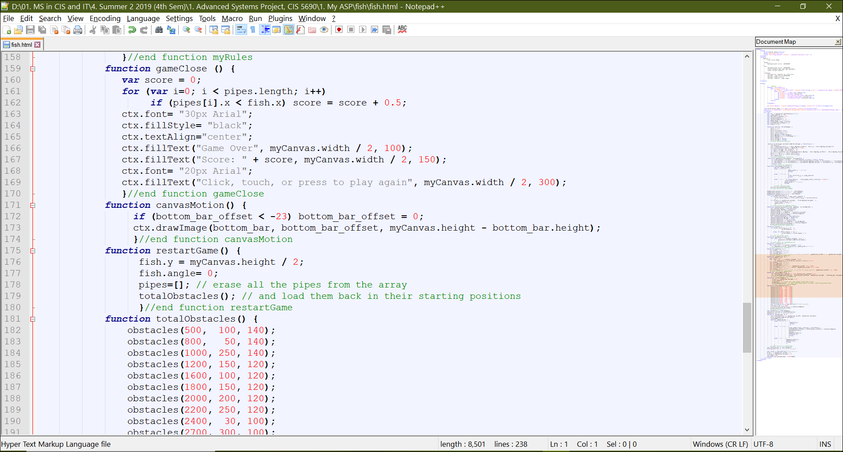

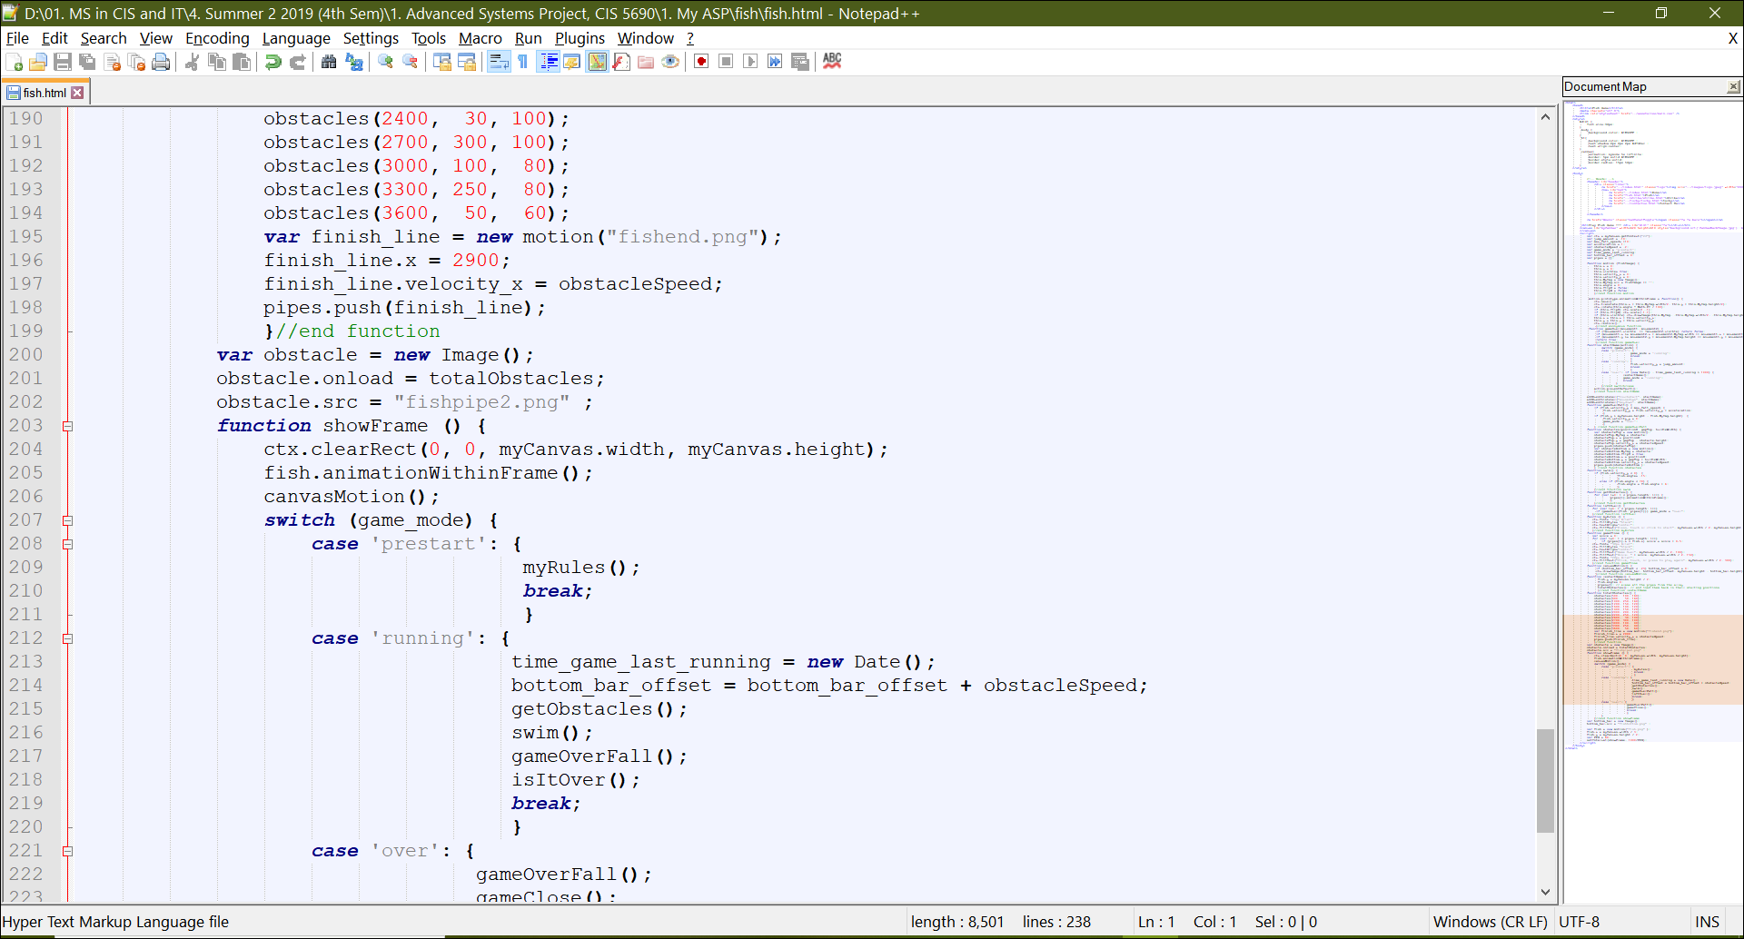

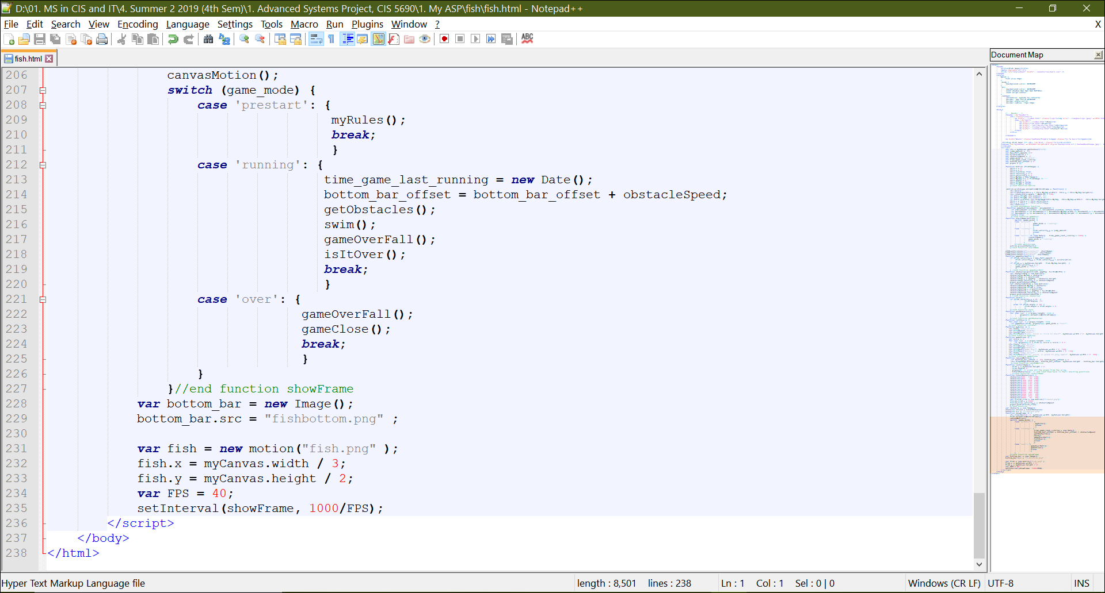

1. When the user clicks Strike Game, he/she is automatically navigated to the game page that looks like the below screenshot

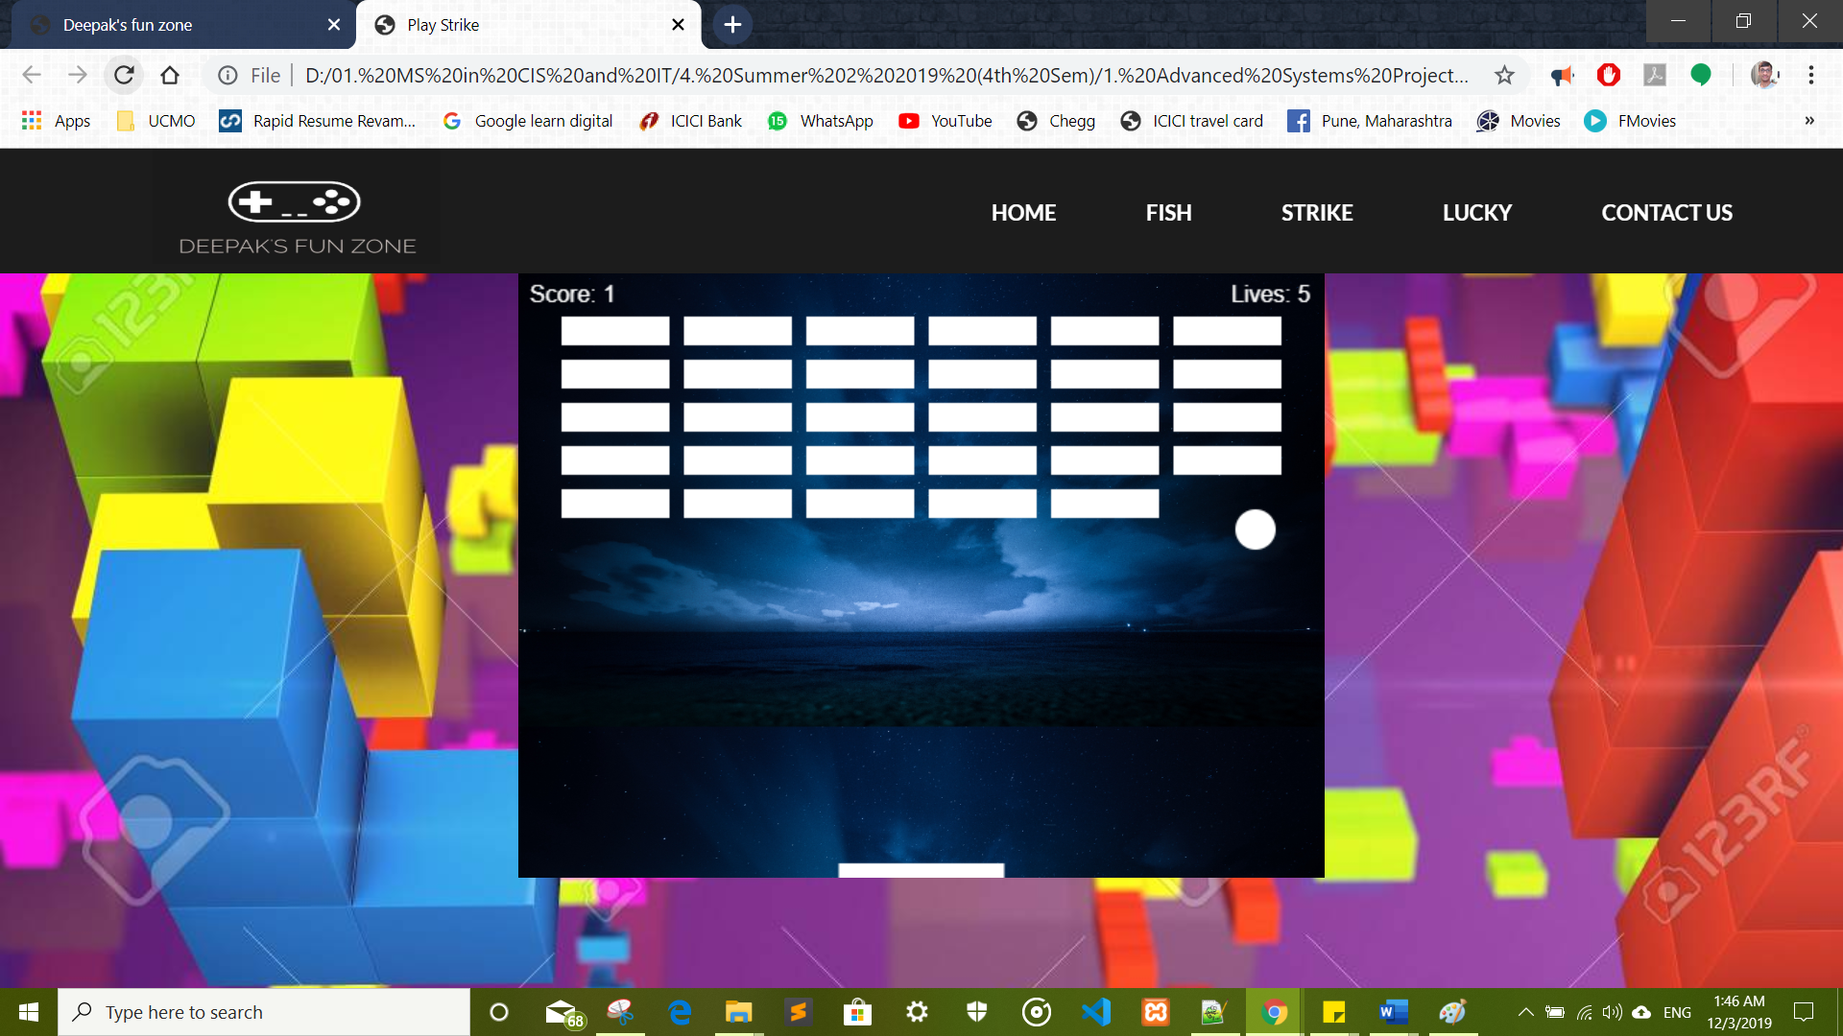

1. The user is required to use the mouse or keyboard as desired to catch the ball on the bar at the bottom

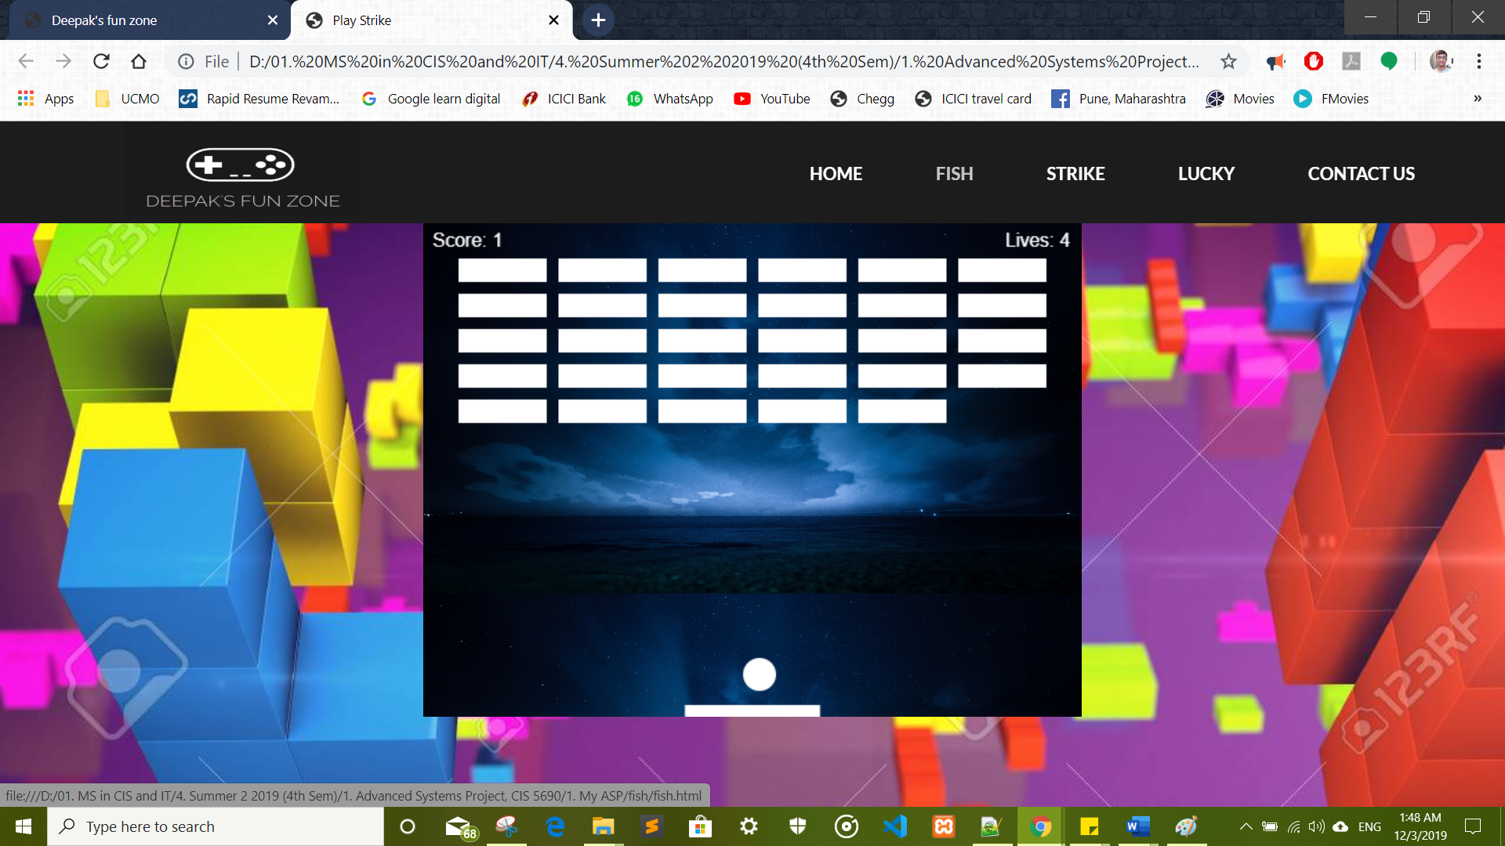

1. The user then hits all the blocks in the air. Every block will disappear after getting a touch from the ball.

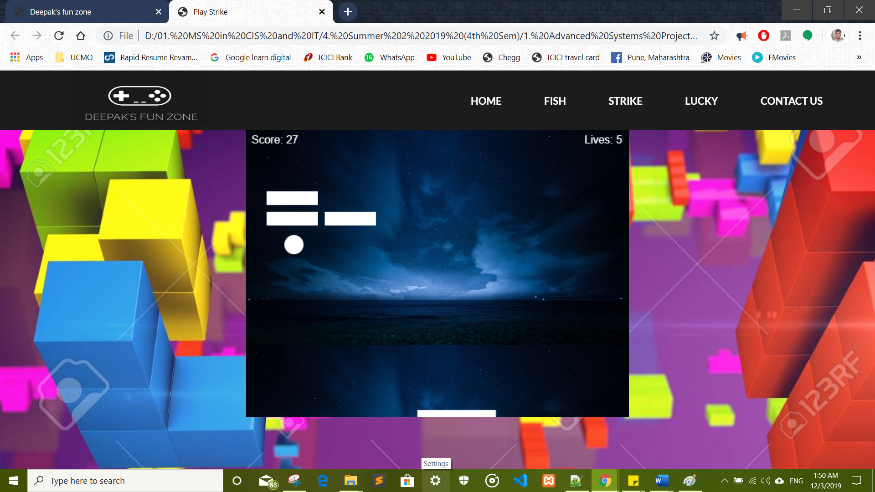

1. Once the user has hit all the blocks and made them disappear then they win. When this happens, a winning alert is displayed in the browser.

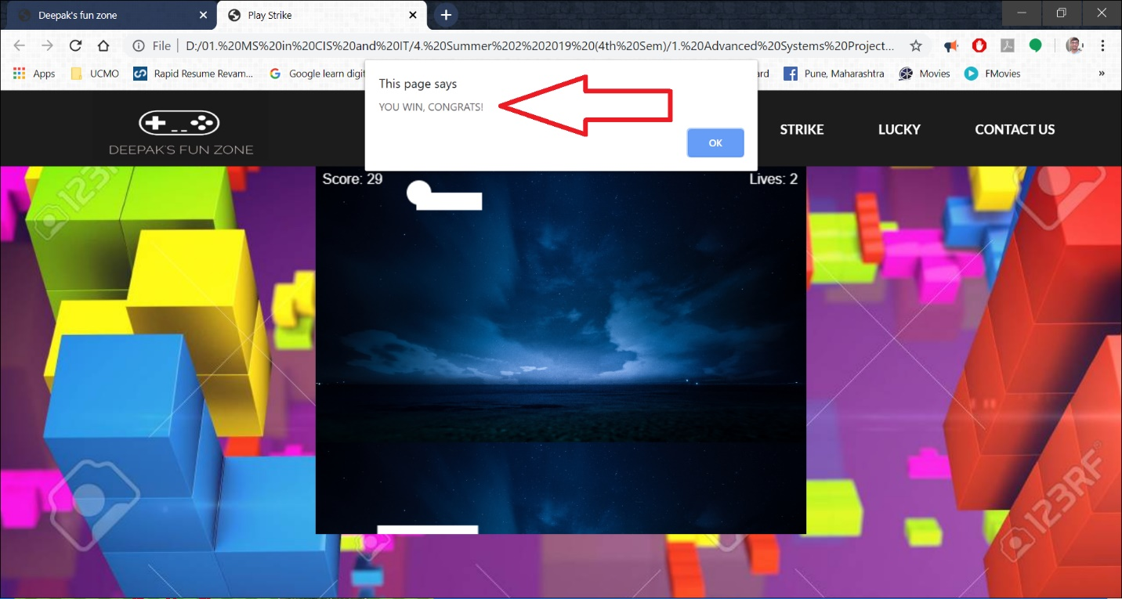

1. The user can see their score in the top-left side of the screen

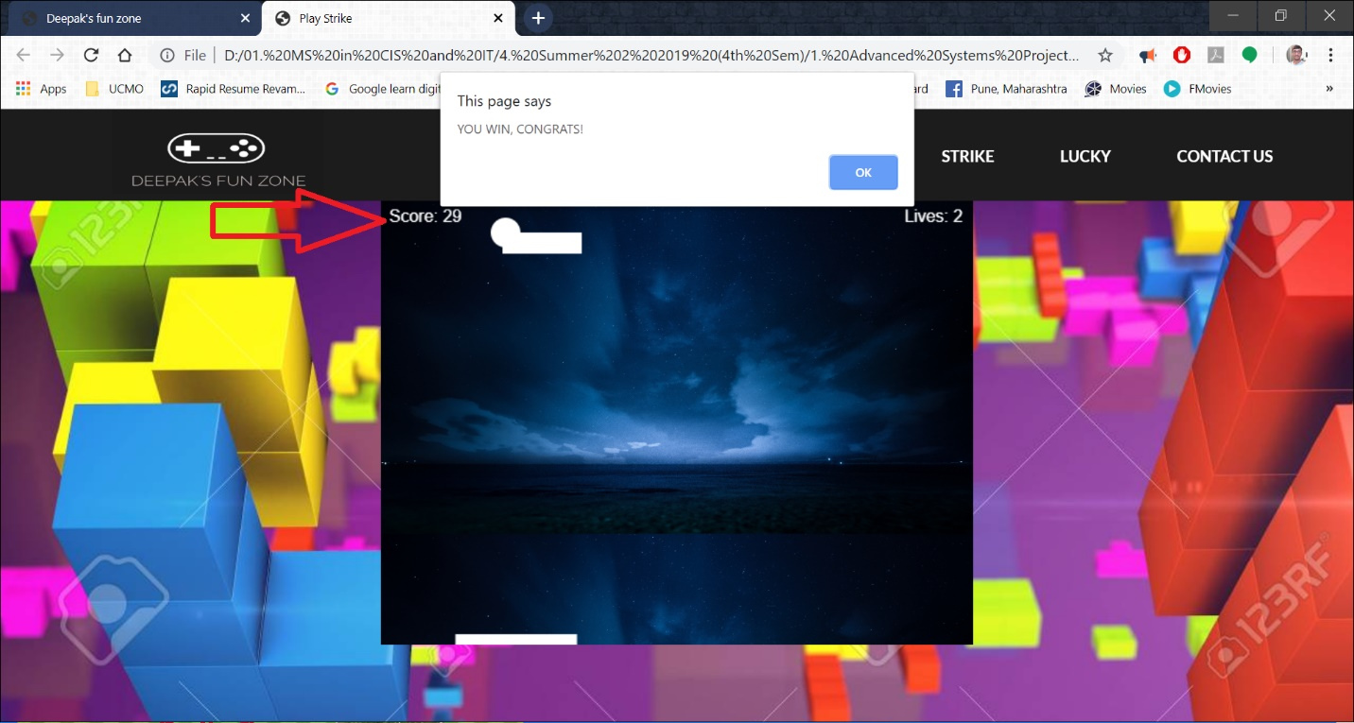

1. The user can see their status of lives left in the top-right side of the screen

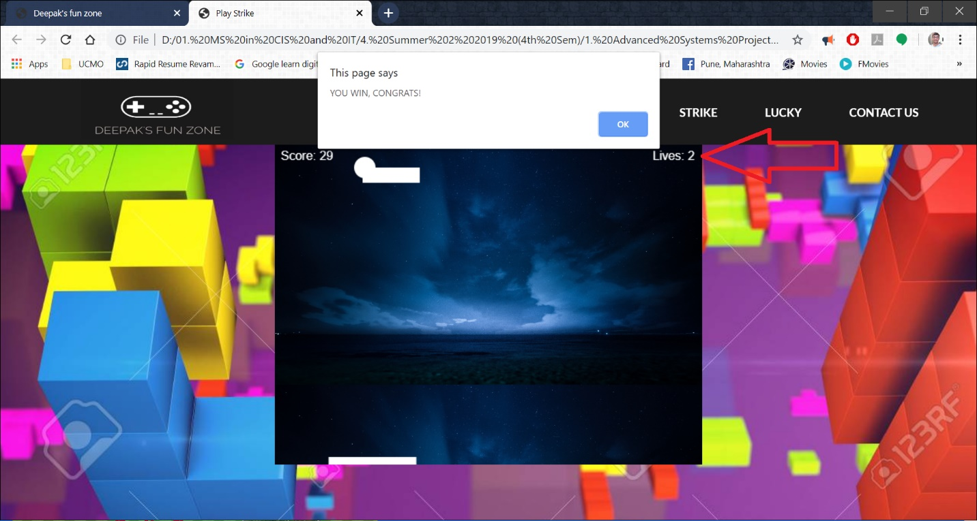

1. Once the user clicks on the OK button from their winning alert message, they can enjoy playing the game again.

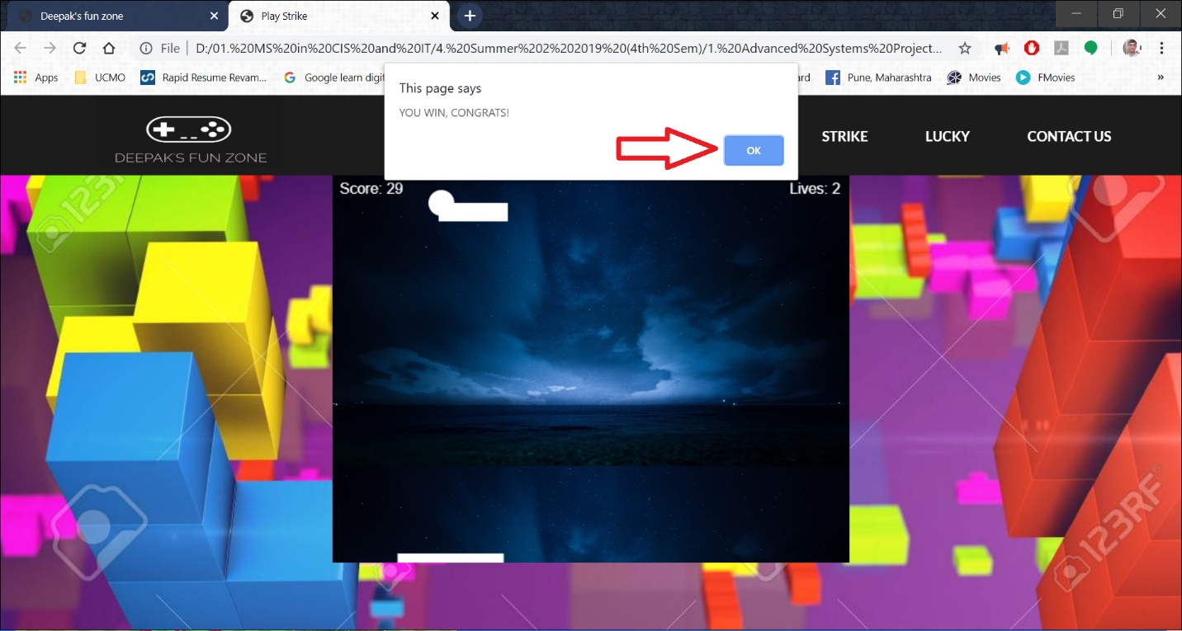

1. The user looses one life each time the ball is dropped below the bar at the bottom of the screen. As you can see in the below screen that the use started with 5 lives has only left with 4 now.

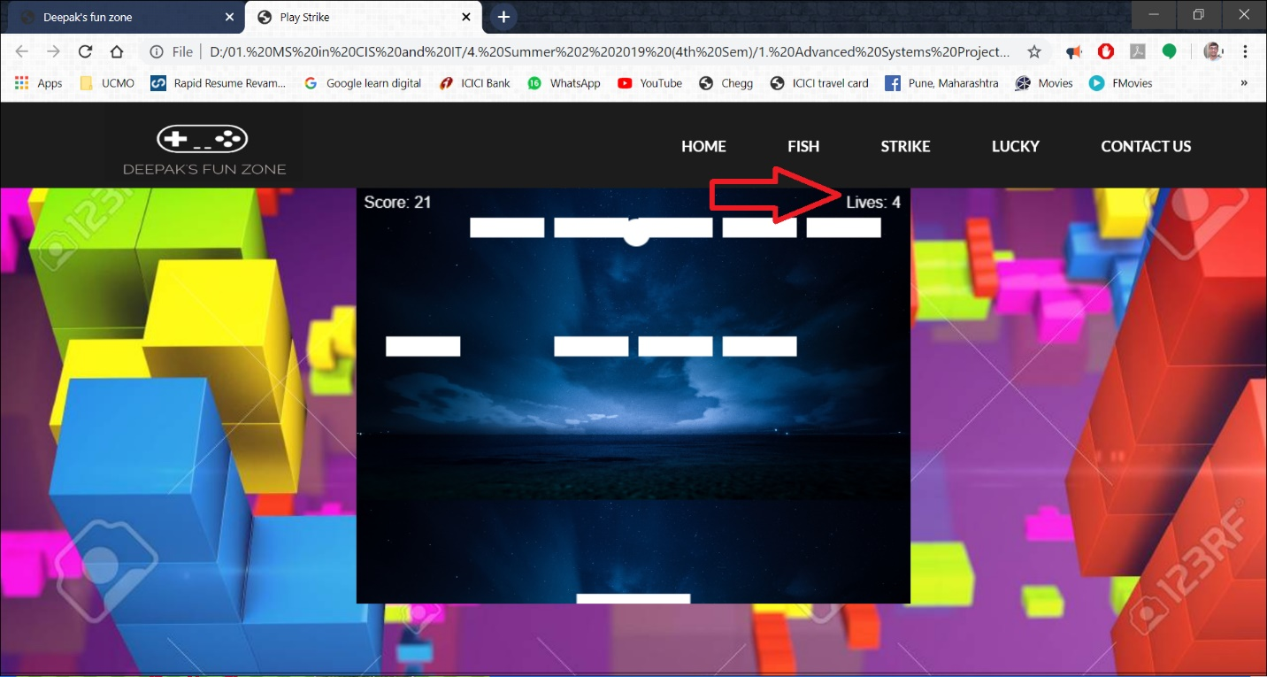

1. If the user cannot touch all the blocks by using their 5 lives, they lose the game. As you can see in the below picture, there is only one life left and the user could not keep up the ball in air with the help of the bar.

Once the ball touches the ground, the game over message will be displayed as an alert to the user.

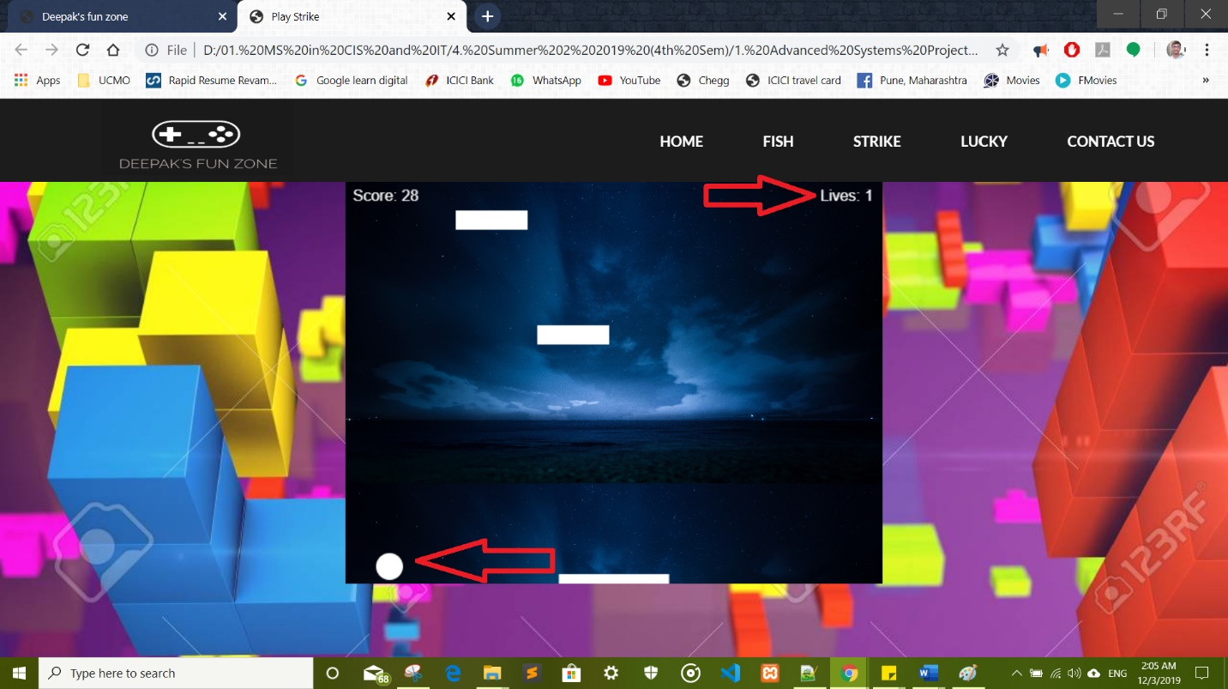

1. The game is over now and the “GAME OVER” alert is displayed

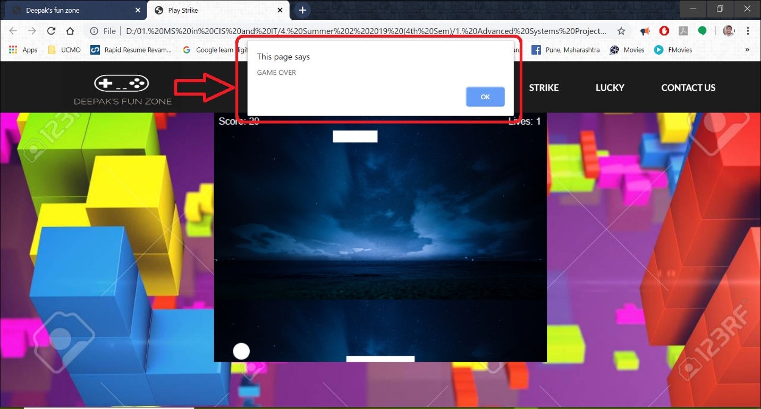

1. Once the user clicks on the OK button from their “GAME OVER” alert message, they can enjoy playing the game again.

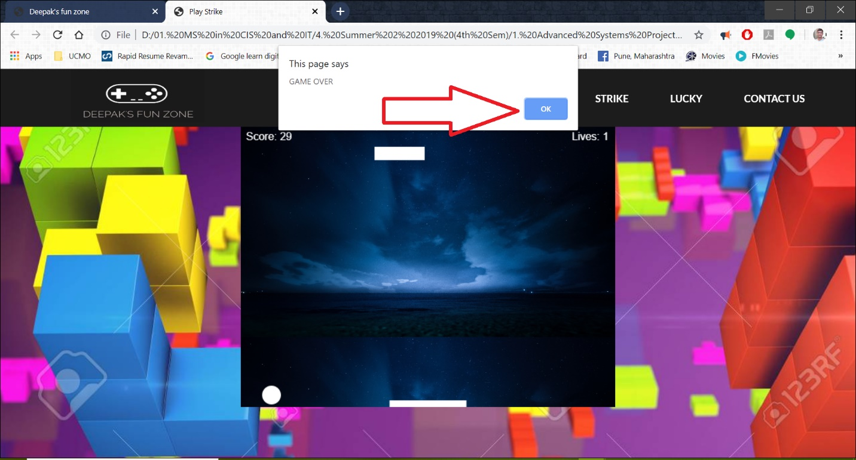

1. The below screenshots are for the code of the game

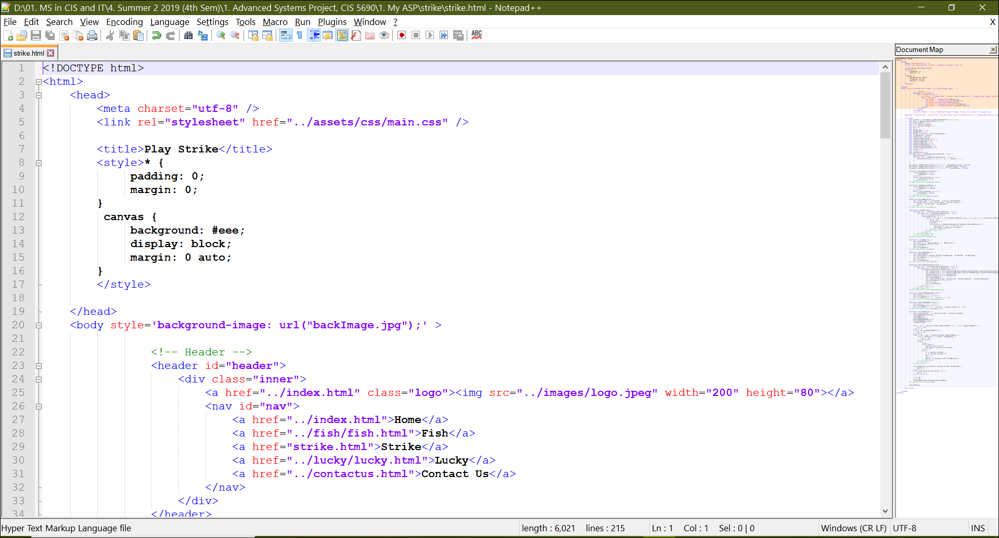

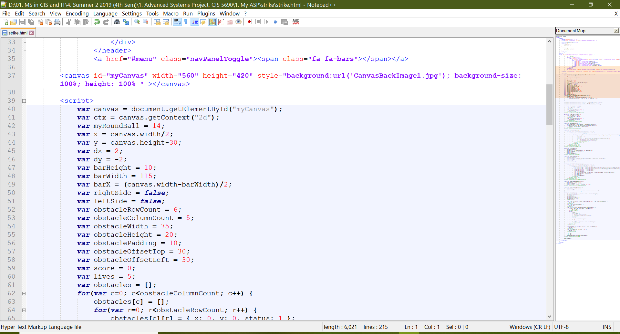

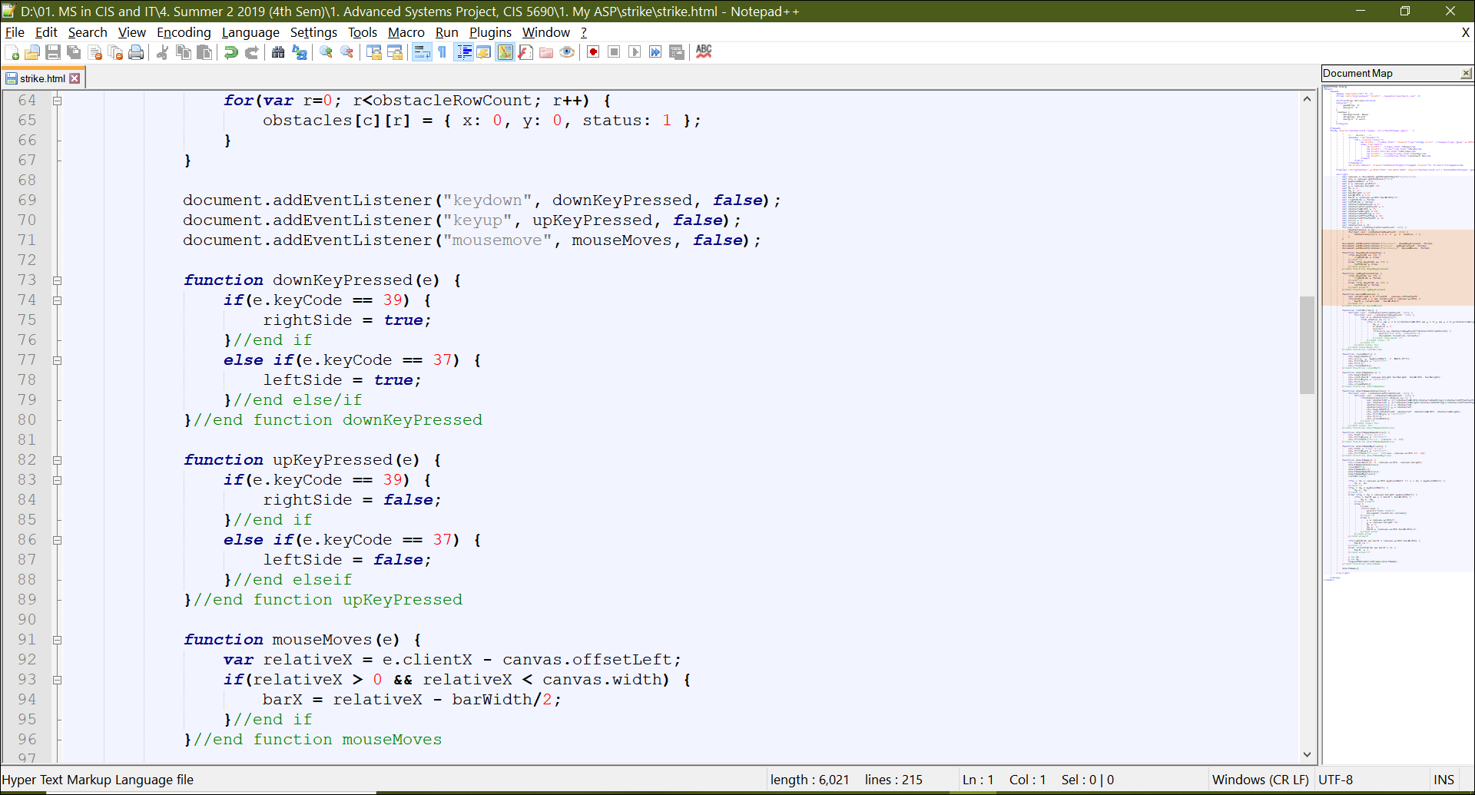

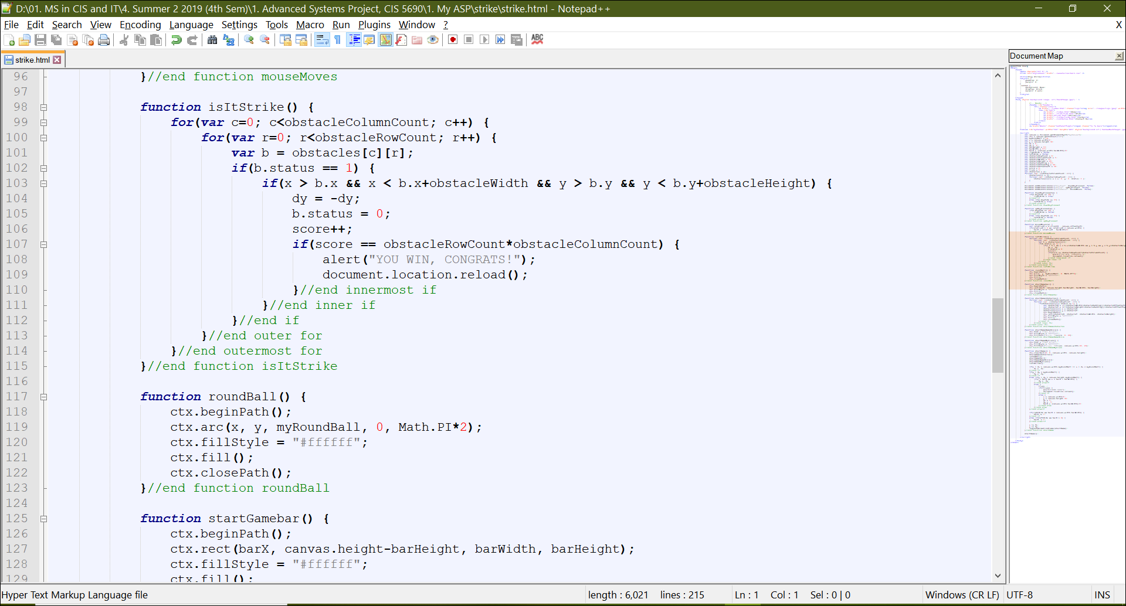

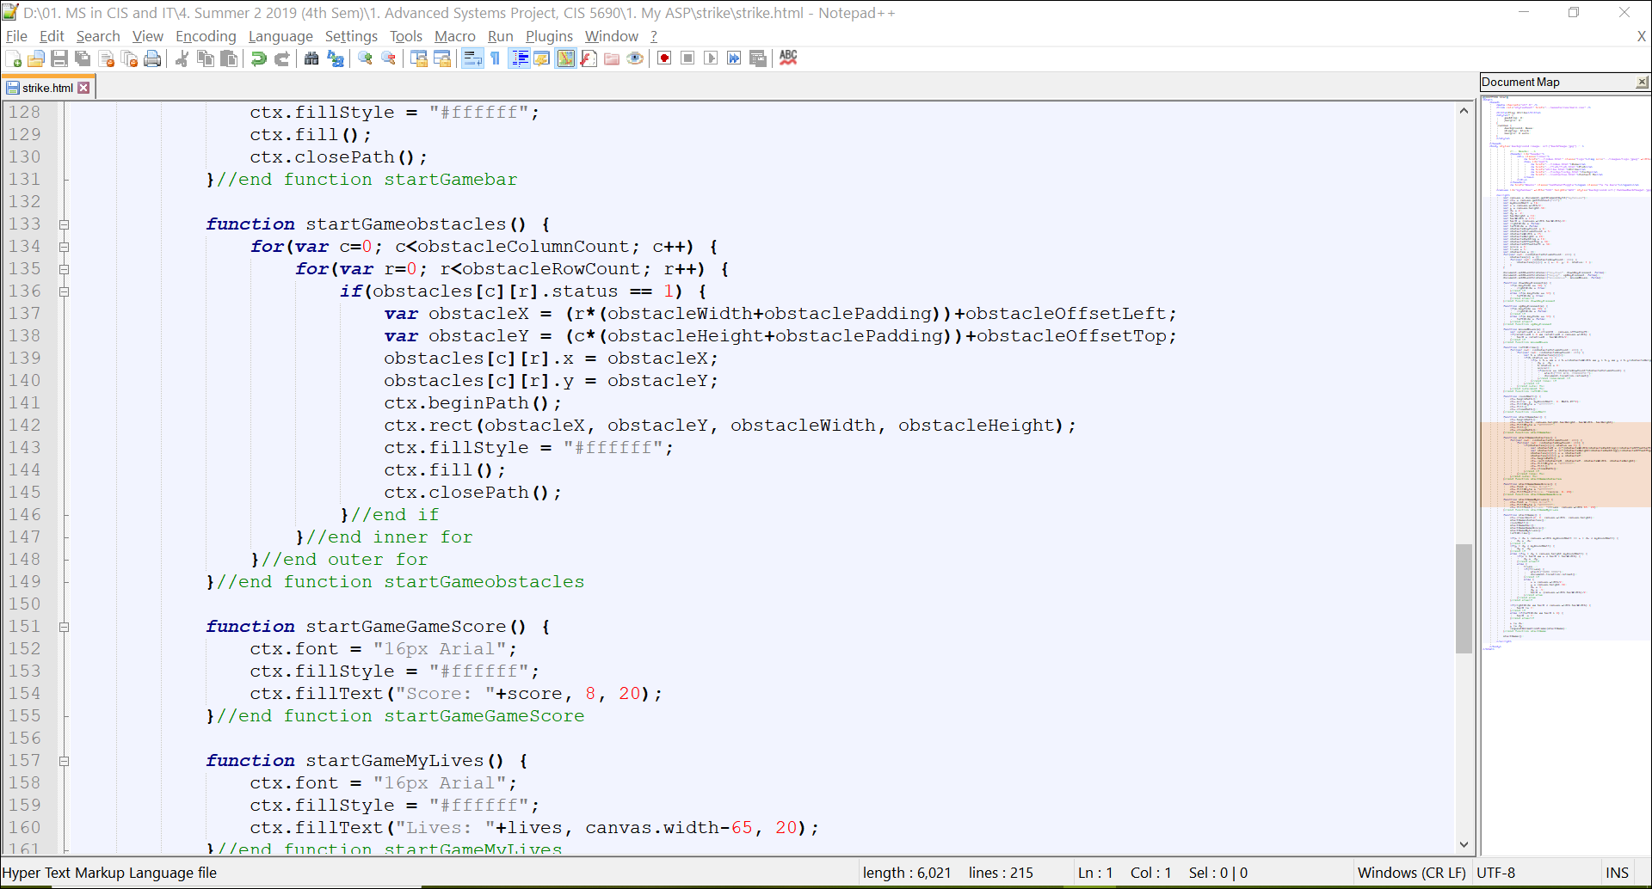

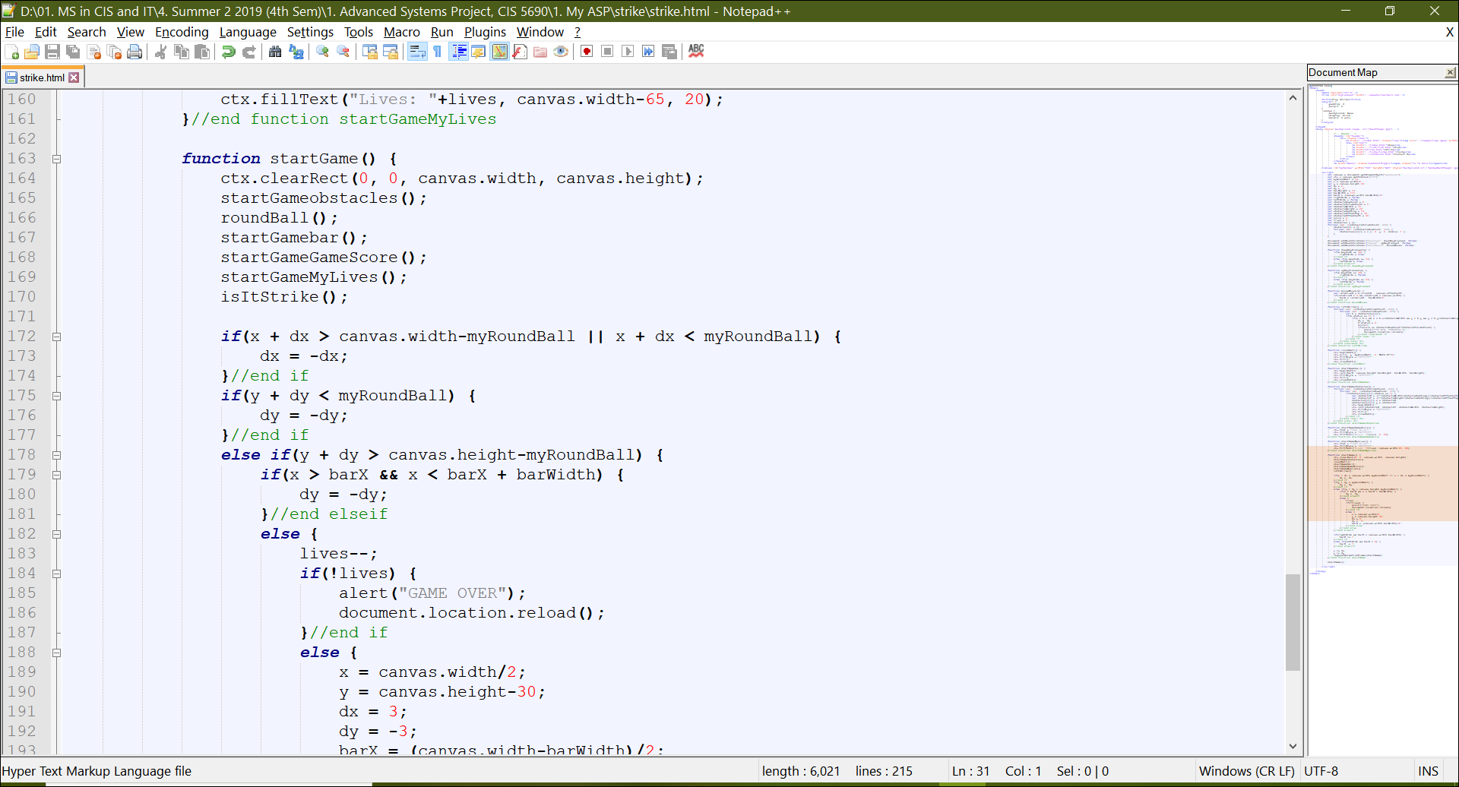

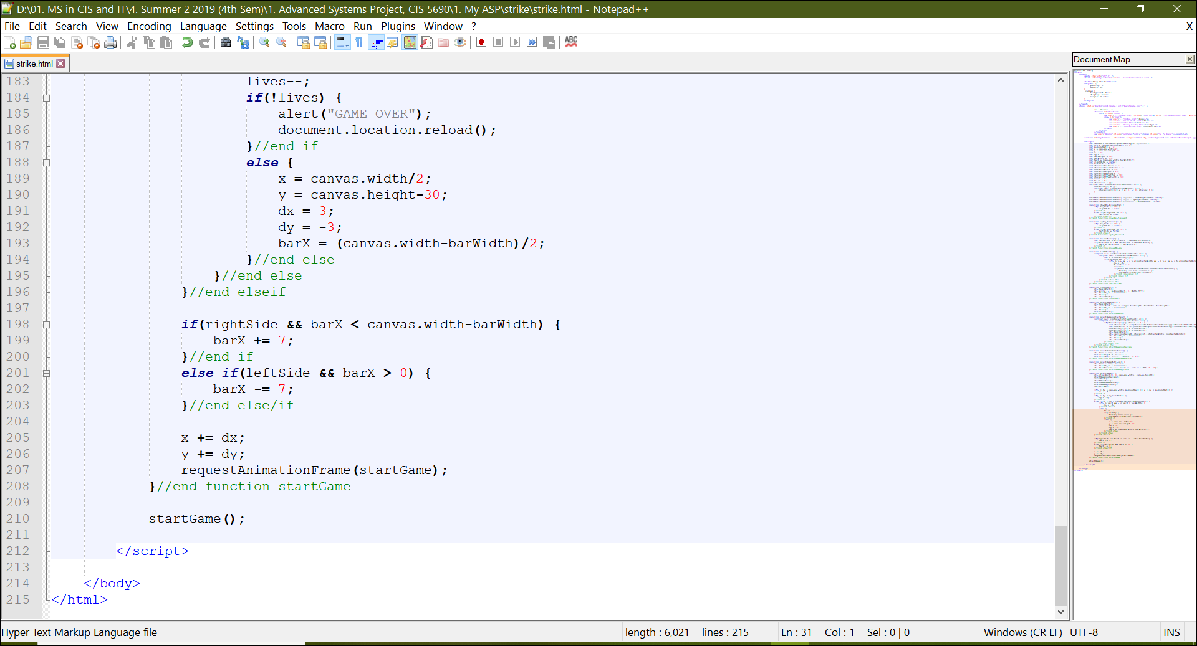

1. When the user clicks Lucky Game, he/she is automatically navigated to the game page that looks like the below screenshot

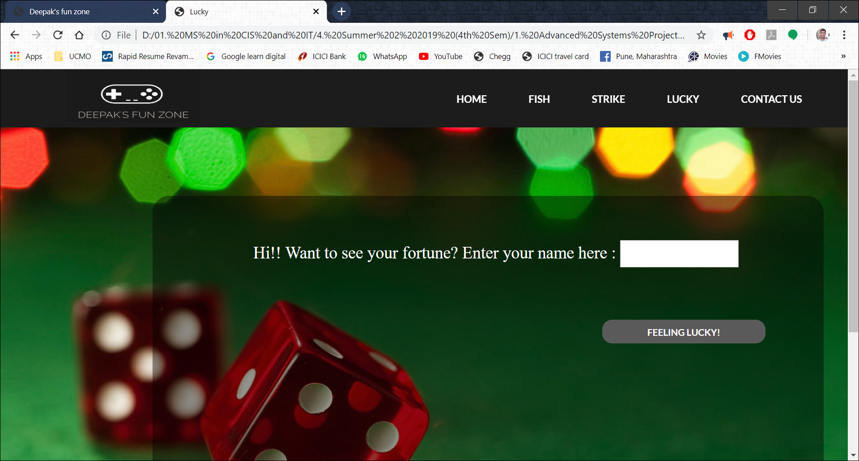

1. On the page it says, - “Hi!! Want to see your fortune? Enter your name here: “.

The user is expected to type in their name in the text box.

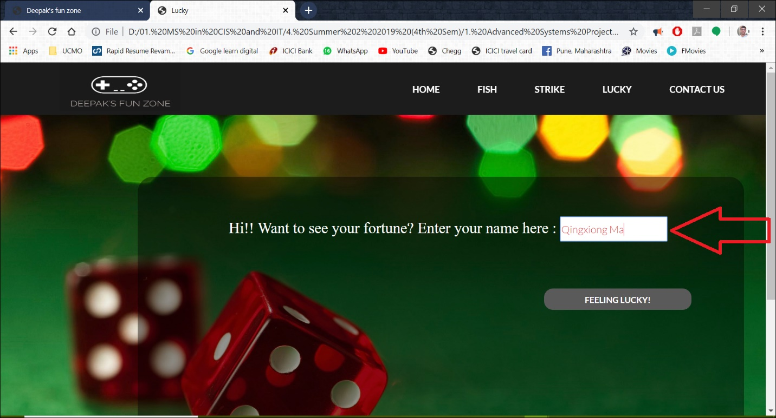

1. Once the user has entered their name in the textbox, they are required to click on the button below that says, “FEELING LUCKY”.

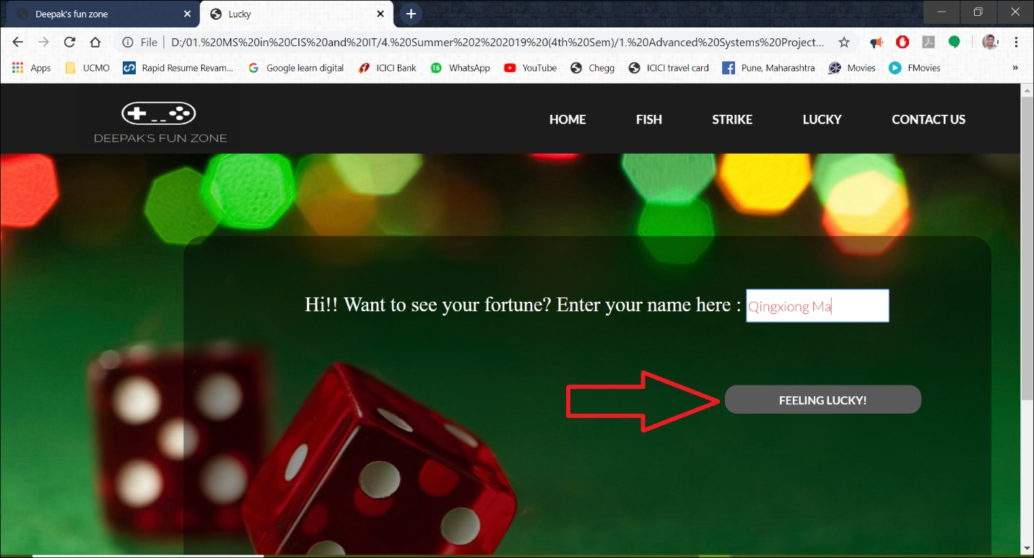

1. When the user enters their name and clicks the button, they will get a response with their lucky number and fortune.

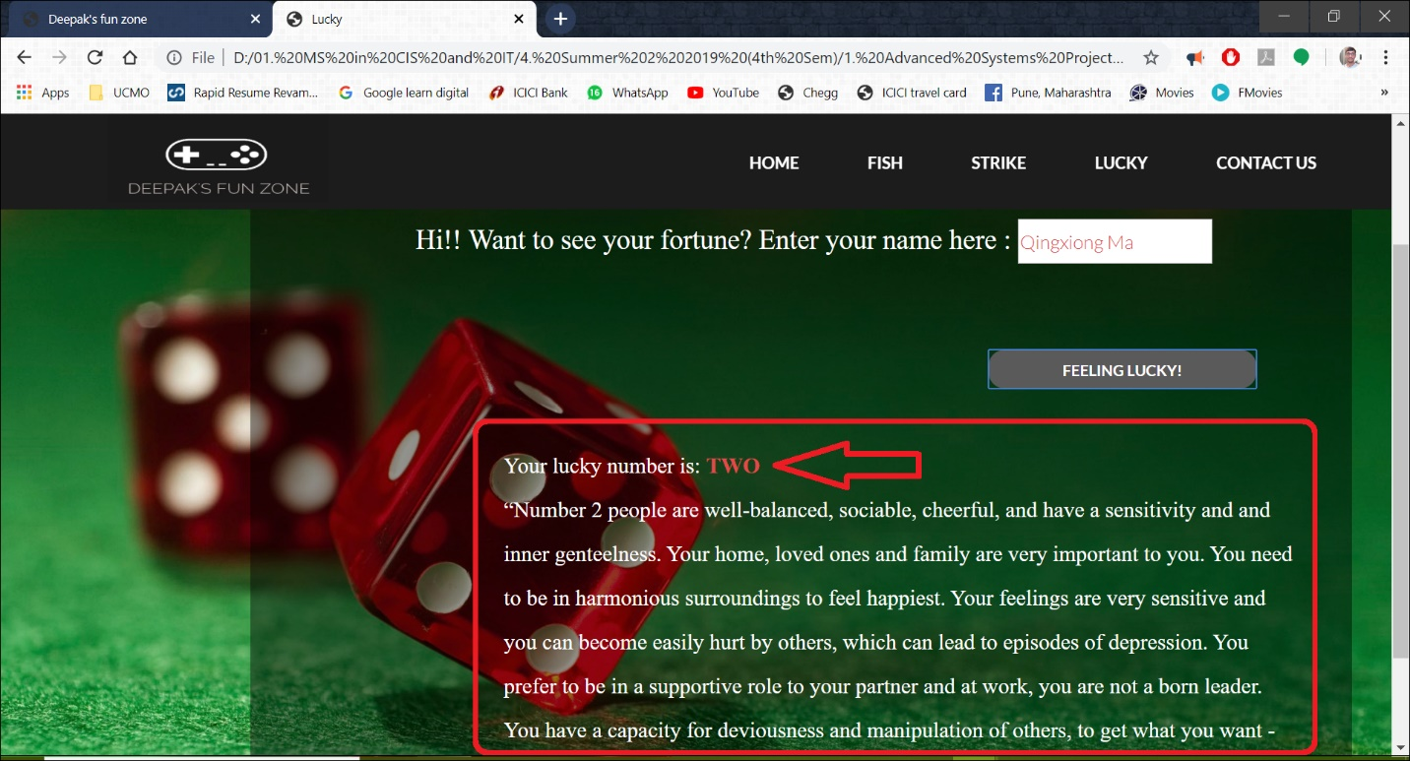

1. If the user enters a number in their name, the page would respond saying that, - “You entered NUMBER in your name...!! Please Enter Your NAME in the above box!”

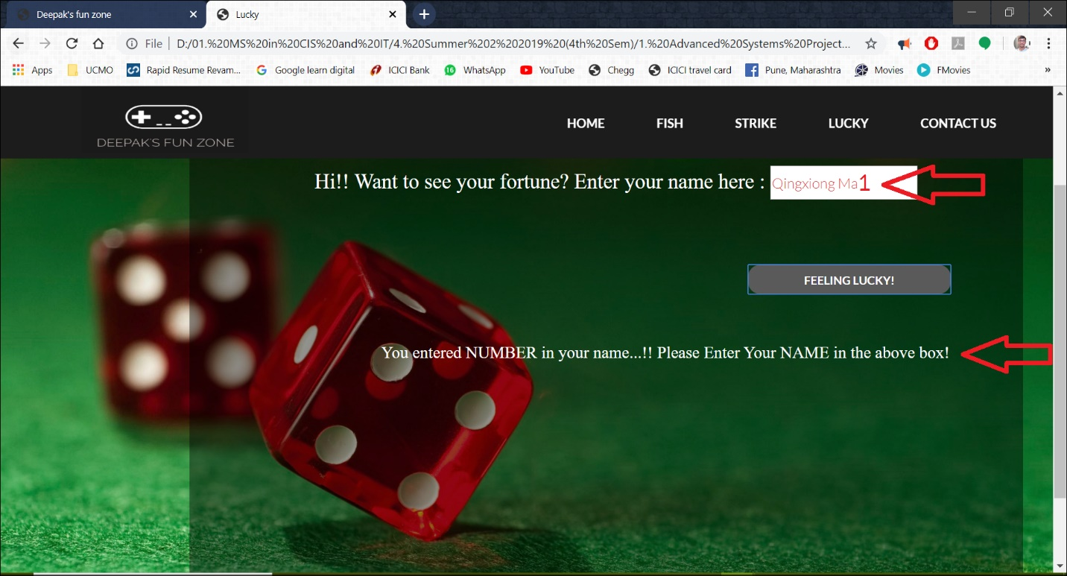

1. If the user enters only numbers in the text box provided to them for entering their name, they will receive a response saying that, - “You are NOT called by a NUMBER, are you...!! Please Enter Your NAME in the above box!”

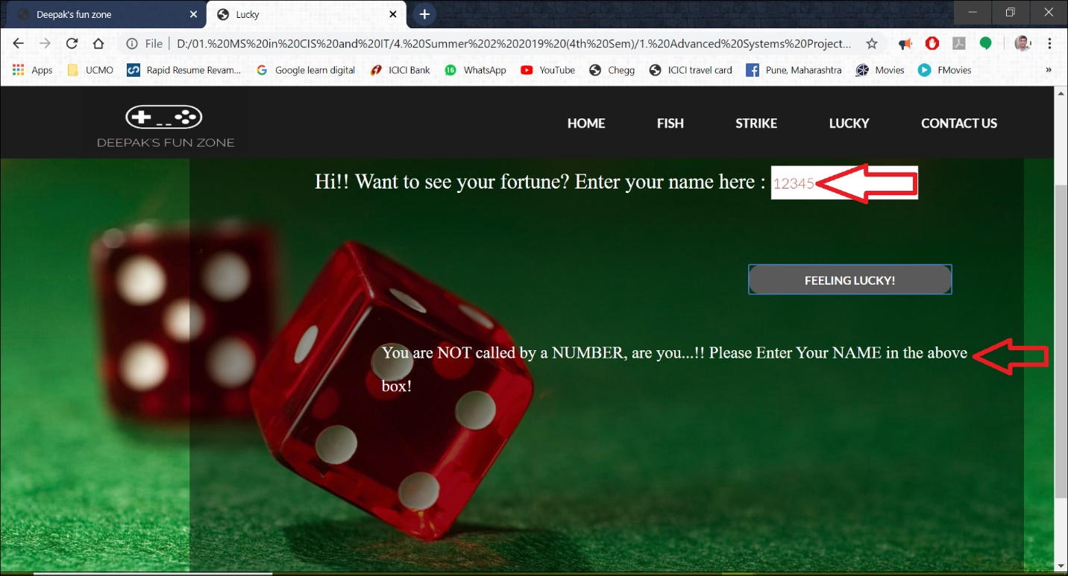

1. When the user doesn’t enter anything in the box provided for name, they will receive a response saying, - “Ohhh come on...!! Please Enter Your Name in the above box!”.

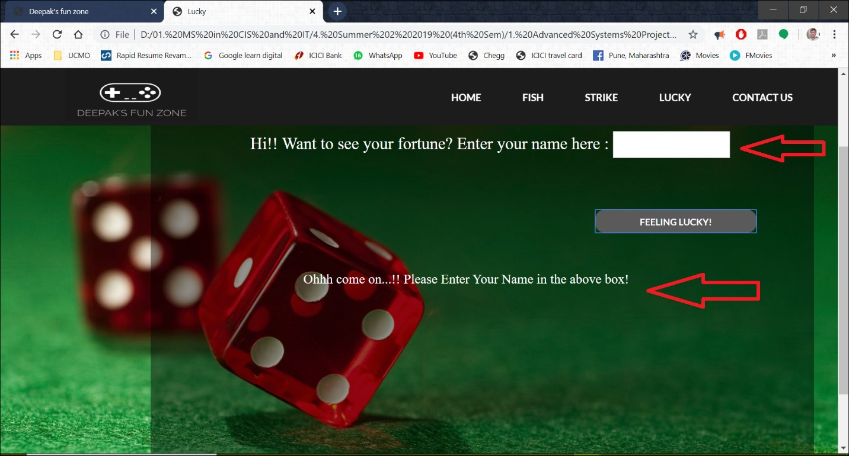

1. Screenshots of the html code for Lucky game

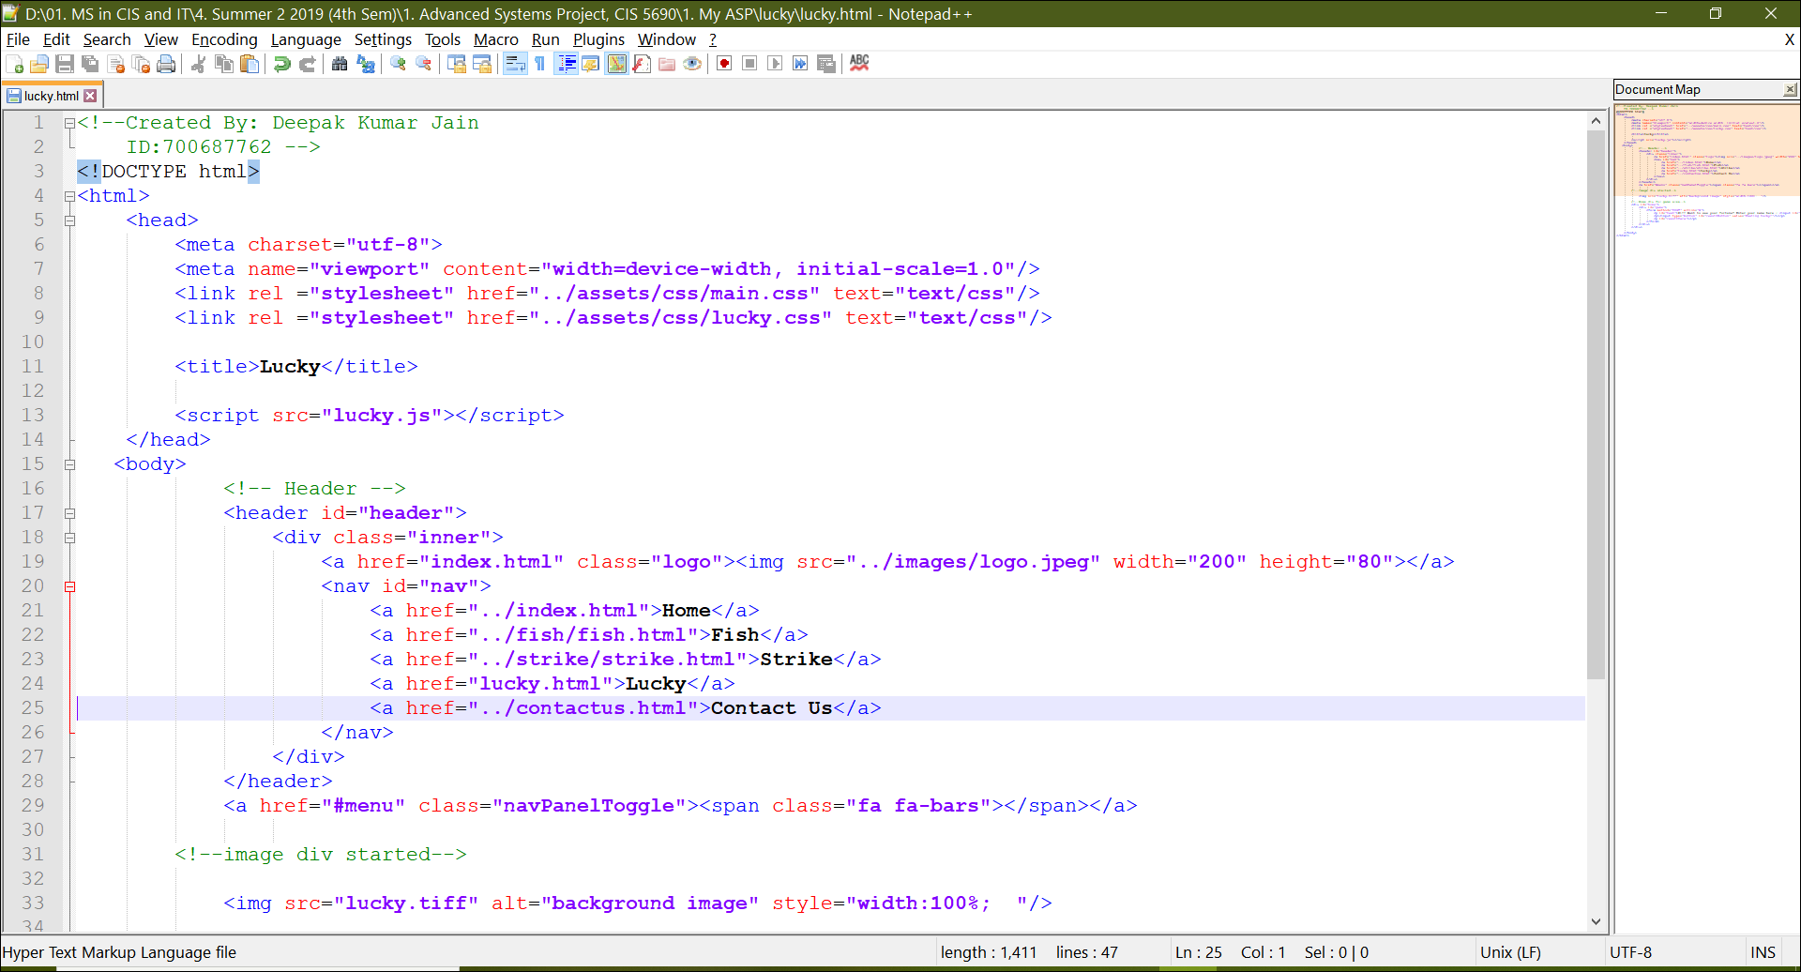

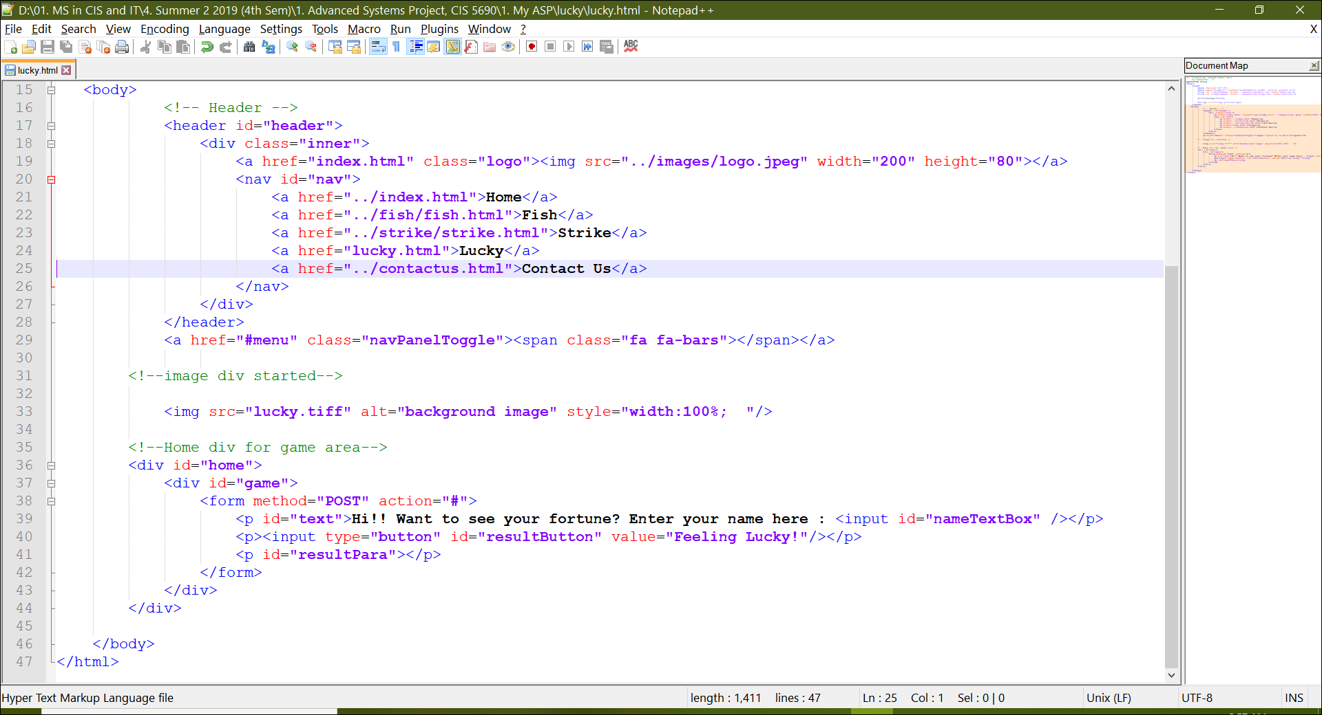

1. Screenshots of the javaScript code are as follows:

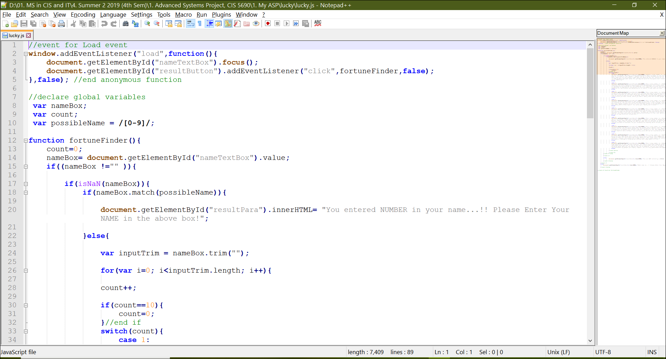

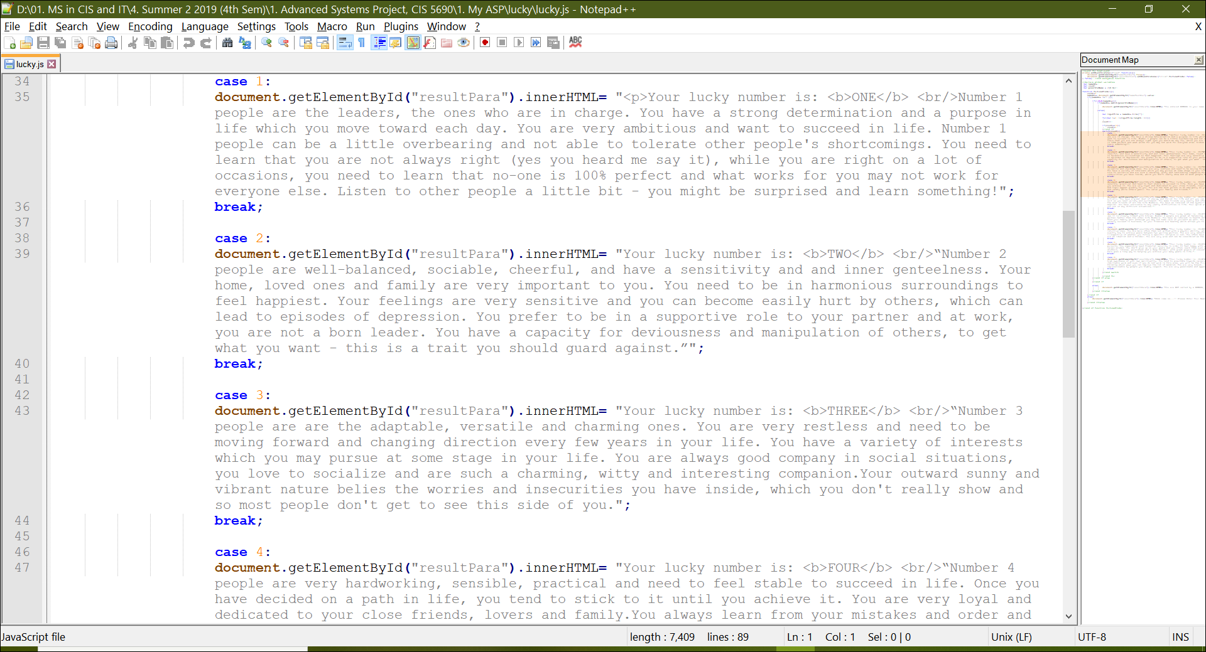

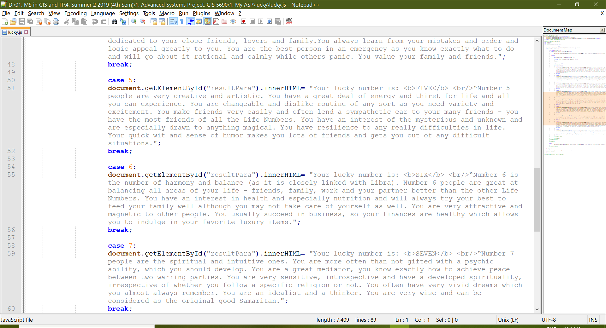

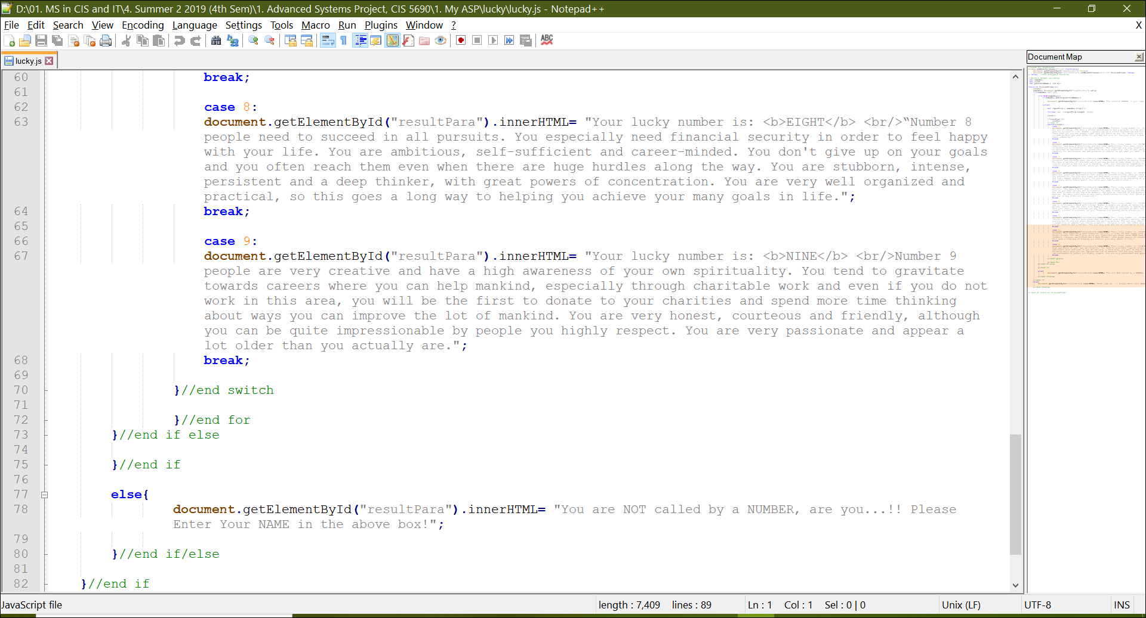

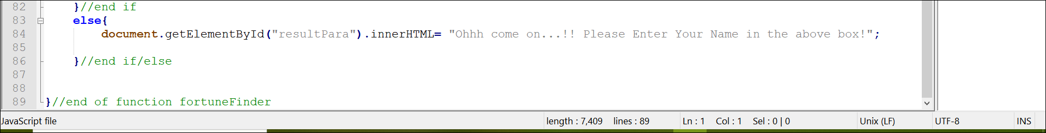

--- END ---